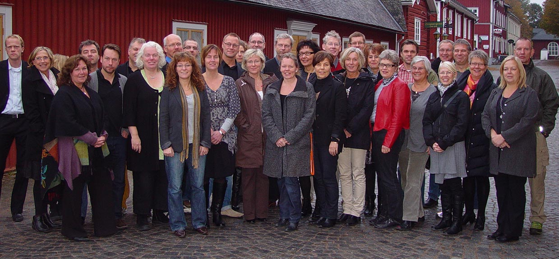

School Leaders in Sweden
– Why do they leave the job and who is appointed?

Mats Ekholm, Erik Groth, Kerstin Lindvall
Karlstad University

2011-03-14

Contents

Chapter 1. Background, aim and method 4
New requirements for school leaders 6
A profession in transition 8
Changes in the governance of schools 10
The aim of the study 14
Method 17
Chapter 2. Mobility among school leaders in the kommuns 22
Summary 26
Chapter 3. School leader positions during the end of the 1900s and early 2000s that were filled 27
Debutant or professional experienced 28
Chapter 4. Women or men as school leaders 32
Looking back 32
Regional variations in patterns of recruitment 41
Variations between kommuns of different size 45
Chapter 5. Educational and professional background of new school leaders 49
New professions as background among school leaders 50
You know what you have …. 55
Number of applicants and the education of new school leaders 60
Chapter 6. Some reflections 62
Education as stimulation 63
Changes that affects 64
School leaders and politicians decide who will become a school leader 65
Weakness that are disappearing 67
The scalability of the School Leader Education 68
Be brave – select young leaders 70
References 72
Appendix 1. Questionnaire to the kommuns 75
Appendix 2. 80

Chapter 1. Background, aim and method

In Europe, it has essentially been three different ways to structure the management work at schools. By far the most common pattern is that every school has one formal leader (Pont et al, 2008). The name of this formal leader varies in different countries. Head teacher in the UK, Director in France, Direktor in Germany, Skolföreståndare at smaller schools in Finland, and the use of the title of Rektor that goes long back in time (from the late part of the 1200's, Ullman, 1997) was used to describe this position in both Finland as in Sweden. The formal leader of a school has been responsible for the running of the work in accordance with guidelines specified by the owner of the school, which European nations generally have meant the state or any other part of society, financed by general taxation. In the traditional European model, school leaders are recruited among the teachers. In most countries and in most school forms a significant proportion of the school leader's job is made up of teaching at the school.
The most unusual way of managing the individual school in Europe has been to allow schools to act without an evident leader. In some cantons in Switzerland, this has been the model used for the schools at elementary level in the school system. The original village school of this country has in larger municipalities and towns been grouped together into larger buildings, but in these larger schools each classroom went on being their own school. The teachers have been largely autonomous and the communities have shown them the confidence to work on their own. Schools in these parts of Switzerland, for example, in the canton of Zurich (Fehn, 1986), have been governed by the local school board and the canton school directorate, but largely at bay. It has been the local school board, chosen by the nearby community's citizens via direct elections, which hired and fired teachers. When this board or the cantonal school directorate needed to address to the elementary school in Switzerland, each teacher received a letter. There was no working collective that could receive a message, but each individual teacher needed to get a letter. It was the teachers in this kind of Swiss schools that took on various management missions, for instance to provide materials or to be responsible for the school's physical condition. Another teacher could be responsible for the schedule planning and still another was responsible for keeping track of teaching materiel. The canton of Zurich decided in 2008, as one of the most enduring of the cantons, to go away from the old model for control of local schools and instead move to the more widely used model of having one responsible school leader with management tasks at each school.
Sweden had for many years a structure at the management work of the school that was nearly as divergent from the internationally dominant solution as the Swiss. During the latter half of the twentieth century Swedish rektors were responsible for the management of grund schools in tiny school districts called rektorsområde (school management area). In such a school management area the rule was that more than one school composed the rektorsområde. Swedish upper secondary schools have generally followed the dominant international pattern - one school, one leader. Other countries follow the main pattern faithfully except for less well populated areas, such as in parts of Portugal. The Swedish solution to let several schools fall under the same school leader, which was common in this country until the late years of the 1980s, had no counterpart in the other sparsely populated Nordic countries. Norway and Finland, which is as sparsely populated as Sweden, have chosen to use the most common European model of management structure in which one finds one school leader at every school in the many municipalities.
The Swedish school leadership work got a somewhat different profile through the divergent structure that the school system had compared to many other countries. The school leaders in Sweden are expected to cover more wide management tasks and also to deal with more personnel than those working directly with teaching. Swedish school leaders came during the 1970s and 1980s smoothly to reduce the teaching part of their profession, that earlier consisted of about half the job to one sixth of the job, to become zero or a very small part of the job as school leader. Many school leaders of the Swedish grund school has become as much of directing managers as head masters of major English schools, where the head master goes back to a cadre of head teachers, which makes it possible for the school leader to delegate the exercise of power to specific teachers. In Sweden, the delegation of leadership is distributed to different teachers, as team leaders, development leaders, pedagogical leaders, head teachers. As the Swedish model assumes a non ever-present leader, the Swedish rektor rely on planning documents, personnel training and performance reviews in a way that one does not always find in other nations' education systems.

New requirements for school leaders
In recent years, school leaders in Sweden have met the expectation to be responsible for introducing extensive improvement of school work. Among the key requirements set for schools in the late 1900s and early 2000s are, for example expectations of grund schools to improve the internal democracy in school, to create more of development oriented working methods for the students and to get better cooperation to work between the teachers at school and between them and the students. During the school reforms introduced three decades back in time, politicians also requested that a more systematic design of the local school activities will be developed, that schools should evaluate their work efforts and that they should get more students to be able to achieve the goals formulated at the center of the target documents. To be able to live up to these and many other ambitions school leaders need to lead their staff so that they are replacing some old habits with new ones.
Most of the expectations over the last three decades focused on school leaders have meant that society representatives - politicians and government agencies – have come to view school leaders as managers that work very much in line with managers in other modern organizations. Already a quarter of a century ago the Swedish National Board of Education noted in a submission to the Government about a new state funding system for school leaders, that the main task of the school management body above all consisted of supervision of work, management and development. The main task was then to be
"to develop school activities in such a way that the local work is operated in accordance with the centrally specified direction. This places increasing demands on the administrative ability of the school leader to coordinate and plan, and thereby delegate responsibility and labor. For the moment, the possibilities to delegate responsibilities and tasks are not very well adjusted to the requirements. A reallocation of school management tasks within the school community is demanded, so that school leader function develops from one "leader" to a team of leadership. It is an advantage when the structure of the school management body can be adapted to local conditions. The regulatory system should be given a general character and above all emphasize coordination, planning and resource allocation as an instrument of the central task for the school management, namely the local shool development. " (p. 5, Memorandum 1984-04-06 from the National Board of Education to the government.)

The central State agency further noted that the school management needs to exercise its leadership so that the inner work reaches the standards that society has set. To cope with this task requires that the leadership is conducted in a systematic way. School leaders also need to be able to work in such a way so that schools find ways of improving collaboration between themselves and other organizations.
During the late 1980s and the beginning of the 1990s the kommuns took over the responsibility of school activities from the state. The expectations on local school leaders to act as a modern organizational leader – which skillfully develops employees and motivates them to cope with the tasks that they face – was not reduced. Rather, the demands on school leaders were increased. They were expected to have a greater economic awareness and to get employees to act in such ways that the schools were brought closer to targets that have been set for school work since long.

A profession in transition
The school leader profession has in the past fifty years come to change the character from being a sideline of a public school teacher or being the crowning glory of an upper secondary teaching career. The change of occupation took place as schools have grown to become relatively large local organizations where at least fifty adults, and in many schools considerably more people, have their place of work. A Swedish school leader is the manager not only for teachers with different specialties but also for maintenance workers, school restaurant staff (since 50 years students in Swedish schools each day receive a hot meal at school), vocational guidance personnel, school psychologist, social worker, nurse and clerical staff. Other organizations of the same size as schools have during a similar growth during the same period of time come to develop more wide management bodies. In addition to the direct executive management positions there are, for example in health care and business enterprises such arrangements as planning departments, personnel managers and financial managers. Leadership cadres of these organizations have expanded in line with the general development.
However that has not happened in the world of schools. Still school management bodies consist of a few executives who are supported by some teachers whom had their teaching duties reduced by a few hours to carry out limited leadership duties. Management work in schools is conducted in an atmosphere characterized by high teacher autonomy within a long tradition. At many schools the norms of work that existed in the old secondary schools for a long time and that were adopted by the folk schools when they moved to the cities from the countryside have been reproduced over and over again. These norms prescribe that teachers have a very high degree of independence in their way of teaching. Teachers' work has largely been treated as a high-professional work, where every holder of the profession in the specific situation is the one that can best assess the measures that need to be taken to reach good results. Leaders' actions have in the traditional school been limited to management of necessities and to provide the independent teachers with good working conditions.
During the last thirty, forty years schools in Sweden have been subjected to a culture change in the relationship between organizations' leaders and those who perform the pedagogical work. The change means that the leadership becomes more accepted in the local organization and the school leaders and the teachers at the school have received a lot more responsibility than before to ensure that the school is effective, both in the sense that it is to achieve its objectives and that it will achieve the objectives at low cost. The individual school has become more dependent on teachers' quality of work. In most local communities Swedish schools have been pushed to put forward their own quality in competition with other schools' quality to attract students. In modern Swedish schools school leaders both concentrate on development of the inner quality and to bring the school's self-image of its own competence to others. Since long schools have developed great skill in evaluating parts of the work which is done there, the work of the students. Since a couple of decades Swedish schools face a demand that they need to be skillful also in the evaluation of the work of teachers. During the last quarter century a culture change has occurred in which evaluation work has come to intrude on those who work in schools. School leaders have had and will have a key role in getting the evaluation of teachers' work to be included as a routine in the day to day business.
Changes in the governance of schools
During the period covered by our studies of recruitment patterns among school leaders (1981 – 2007) a wide decentralization has been undertaken within the field of educational policy. Governance of the Swedish school system, which previously was done by top bodies in the school system like the Ministry of Education and the National Board of Education, where diagnosis of problems were made, goals where formulated and solutions on problems were designed, has sharply changed.
The centers of power that now exists at the national level within the education policy field (Ministry of Education, The National Agency for Education, The National School Inspection) are content today to indicate problems and set goals for the inner work, while the more peripheral parts of the system has to find solutions to problems and to implement them. The governance of the school system has moved from an implementation steering based on rules and regulations to a goal-based performance management (Seashore Louis and Van Velzen, 1986). The steering of the educational system has largely changed arena. Previously decisions were prepared and taken on one single arena covering the whole country. Now preparations and decisions are made at nearly three hundred arenas of kommuns, which have had major implications for the school leader profession.
An early forerunner of the decentralization policy that was to take place within the field of education during the late 1900s and early 2000s was the appointment of school leaders. When the grund school was introduced in 1962 the new school leaders (rektors) were appointed by the Government. When Ragnar Edenman was Minister of Education during the 1960s a practice was founded in which the state agencies that prepared the decisions of who would become a school leader – county councils and the National Board of Education – did not receive the largest weight in the decisions. Edenman and later education ministers listened primarily to the reactions on the applicants that the kommuns had. Throughout the 1960s, 1970s and 1980s the kommuns became experienced of being the heaviest body when it came to the selection of school leaders. Posts as school leaders became in 1988 the first state-regulated services that were transferred to the domain of kommuns in the school system and by this also followed a full and entire responsibility for the appointment of managers for governing bodies in the kommuns. The changed responsibility pattern led to changes in the way merits were evaluated and used for the selection of school leaders. In earlier days when state agencies had a say in the process appointments followed more of a mechanical calculation of the value of merits of the applicants. When the kommuns get the full responsibility for the selection of school leaders much more of direct observations and impressions through meetings and interviews with the candidates were used as decision support. The judgments made by superintendents, local politicians and union representatives based on these direct meetings with candidates have become essential for decisions on appointments.
By changing the governance of the school system has not only the arena for education policy changed but the actors of the policy process have taken new positions. New actors have entered the education policy arena. The kommun politicians who have to decide on the direction of local school activities, today not only face a "teacher thinking" when the dialogues of steering with the school leaders go on. They meet such thinking that has emerged among social workers and psychologists as well as among vocational guidance personnel. The meetings between these traditions of thought and those of the local politicians have provided education policies with alternative insights.
Towards the end of last century, while education policy shifted figure, in many kommuns a new fashion for how to act politically showed up. On basis of thinking derived from business administration, which spread mainly to the kommun superintendents of schools and local politicians through the consulting company Sensia, owned by the Association of Swedish Kommuns, principles of local government activities were stressed like that they would be cost effective and that the ownership and implementation would be kept separate. In the Sensia ideas it was also argued that goal management would be developed to become steering through ordering with clear agreements explicitly specified in contracts. Efforts were made to break up the coupling between the board and the school management bodies and to minimize the grant steered part of the kommun operations. The production of the kommun would preferably be under competition and the units organized in some kind of “outcome units”. In this well marketed “thinking fashion” for kommuns it was also included that sub boards of the kommun ought to be structured on basis of target groups as far as possible. The latter principle has led to that the country still suffers from linguistically strange local phenomena such as “child and youth directors”, “children and school administration” and ” individual and social care authorities”. The many new possibilities structuring the inner life of the kommun appeared in the late 1980s also come to dissolve the school leaders' profession as new and rather interesting professional titles were invented to fit the new way of structuring the inner life of kommuns and schools. But before so actually happened the Minister of Schools in 1991 declared that each school should have a rektor who bears management responsibility.
The rhetoric behind the changes that have resulted in the restructuring of leadership in school has been clear. Education Ministers from several political parties have argued that schools gain from a closer leadership. It would support the improvement of the working situation in schools. The rhetorical attack began in the 1980s. Minister of Education Bengt Göransson wanted to see school leaders in the middle of events. As a model for the level of leadership, Göransson had his own years in the tourism industry, where he served as branch manager. By being close to and preferably in the middle of problems, these could be solved through direct actions. To lead by walking around was a lingering philosophy. Far-reaching decisions on decentralization of the school system were taken during the next government period (1988 to 1991), when Minister of Education Göran Persson laid the foundation for change in many kommuns. It was during this period it was stated that there should be one school leader on each school site. The demand that there should be a more close leadership at the local school by many kommuns was interpreted so that the former internationally exceptional system of having school leaders who were managers for many school buildings was left. The dismantling of the earlier school management areas went on in the 1990s with great speed in many parts of the country and the wide spread principle of one school – one school leader was quickly adopted. In some kommuns, however, the local politicians resisted the siren calls from Sensia the call for more close leadership sent out by the Minister of Education. In these kommuns one has maintained the school management areas and have given school leaders a wider mandate than only manage the inner work of one school. In the new situation that arose when the kommuns were restructuring their internal systems of school management many positions of school leaders opened for new holders.

The aim of the study
The work that leaders of local organizations are engaged in or permitted to carry out is relevant to the performance of the local organization. Importance of leadership has been shown in research both on profit organizations (see eg Beairsto, 1997) and on organizations in which providing care or education are the main focus (Reynolds et al, 1996). At the University of Karlstad, several studies have contributed to the understanding of the impact on the development and performance of schools that school leaders have (Ekholm, Blossing, Kåräng, Lindvall and Scherp, 2000). Among other things we have been able to show that the behavior of school leaders are of significant importance to the ways gymnasie schools improve the quality of teaching (Scherp, 1998) and that the quality of actions of school leaders in grund schools covariate with student performance on knowledge tests (Kåräng, 1997).
School leaders impact on their own school environment and local culture is certainly not only determined by the way in which the individual exercises the professional role as a leader in a school, but the effect of the leadership is largely determined by school members' ways to accept and respond to the local leadership. The interactions that is developed or not developed between the school members and the school leader will be critical for the quality of the inner work. Sometimes it is evidenced that schools are workplaces where the acceptance of leaders and leadership in relation to many other sites are low. The tradition among the dominant profession in the schools – the profession of teachers – is that each one handles the work in your own way. The task of the school leader is to provide teachers with a good working situation. If the assumption that teachers have a hostile attitude towards school leadership is true you would expect that many school leaders would leave their positions. During the past decade, in various contexts you have seen reports that the turnover of school leaders has been large in Sweden. In 2003 for example the National Agency for School Improvement (Report 2003-05-05, Dnr 2003:234) reported that 16 per cent of rektors in grund schools and gymnasie schools had finished in 2001/2002. Some statistics for school leaders in the pre schools were not shown. The School Leader Union (Skolledarförbundet) reported 2007-03-19 that 43% of school leaders during the period of 2000 to 2006 had left their jobs. In a comment to this survey the Association of Swedish Kommuns claimed that their statistics showed that only 3% of school leaders left their employment each year. In a later study in 2007 The School Leader Union claimed that 71% of the surveyed schools had changed their school leader at least once during the period 2001 - 2007. Any deeper analysis of this alleged mobility has not really been made, although the figures should be regarded as sensational. Allegations are, however, that the high turnover of school leaders and the departures from these positions depend on the inbuilt impossibility of the school leadership position. This impossibility consists of the cross-fire that school leaders exist in between result-focused politicians and autonomous teachers who require servility by the manager.
Although the interaction between leaders and school members are most important to study in order to be able to understand and explain how leadership affects school quality, it may be worth paying attention to the more general, although individual, experience that school leaders carry with them into their work as a result of the recruitment and appointment procedures employed in the Swedish school system. Some experience that is highly valued in an appointment system can have positive impact on schools' ability to achieve their aims. Other experiences that are highly valued may have a less positive impact on this ability of schools. In a healthy school system, it is natural to carry out critical studies of the patterns that occur when the rich amount of responsible forces in different parts of the system are acting in good faith on their own to serve the system best. By creating overview of what the many different decision-making bodies have succeeded to do and examine the patterns that have occurred in the system makes it possible to hold a discussion about the school system's intrinsic strength and weakness when it comes to leadership.
The purpose of the studies presented here are
- to illuminate to what extent the statements being made about departures from the school leadership positions are authentic and also illuminate if the departures from school leader work is related to the perception that that kind of work is difficult or nearly impossible to perform;
- to clarify which appointment patterns that have existed and which ones that actually are used in the Swedish school system for school leader posts during the latter part of the 1900s and the beginning of the 2000s.

The emphasis of the illumination of the departures from the school leader posts is placed on school leaders' views on the work and the work situation as they leave. The emphasis of the investigation by the appointment patterns is placed on studying what is permanent and what has changed in these patterns within kommuns in terms of school leaders´ gender, professional background and demographic belonging. The study reflects mainly the local politicians' behavior when they have decided who they will appoint as a school leader. With images of responses to school leadership work at the end of an occupation period together with pictures of changes over time in the selection patterns, we want to contribute to the debate on what effects the selections of new school leaders may have for school quality. The study is part of a larger international study. When the other nations (Denmark, England, Ireland, the Netherlands, Scotland and USA) involved in this have reported their results, a comparison with other countries will be presented.

Method
To illuminate the reasons behind school leaders leaving their posts, we have during the second half of 2007 and first half of 2008, performed case studies in fifteen of the sixteen kommuns in the region of Värmland (S on the map) in Sweden.
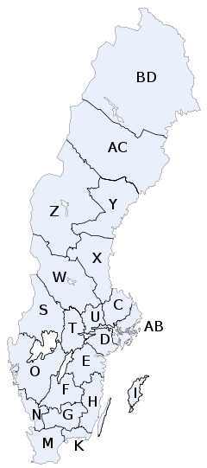

This study was made in collaboration between the fifteen kommuns of the Värmland region and the School Leader Education at the University of Karlstad. It went in three steps. In the first step all school leaders of the fifteen kommuns were mapped out in terms of gender, age, previous experience and the leadership training that each school leader had undertaken. In a second step, the local school leaders responded to a questionnaire about their satisfaction with their work and work situation. The results of this survey were reported to each kommun, while the collected material came to form the basis for the further analysis of the reasons why some school leaders left their positions. In the third step in this sub-study the kommuns reported to us during the school year 2007/08 as soon as school leaders changed job or left their post in the kommun. Thirty school leaders actually left their posts this year and each of them was contacted for an interview. Twenty-four school leaders participated in the interviews, which mean that we had a shortfall of six of the thirty who ended their posts this year. During the interviews issues concerning the reasons why changes were made both with regard to the experiences of the previous post, as to plans for the future were in focus.
As part of the research work being conducted at the University of Karlstad and which also earlier took place within the National School Leader Education (Ekholm, 2007), we have studied how the recruitment pattern among school leaders in grund schools and gymnasie schools has varied in Sweden since the early 1980s. The studies have been performed as surveys in which written questions have been addressed to the authorities responsible for the recruitment of school leaders. The previous investigations have continuously been reported (Ekholm and Lagervall, 1983, Ekholm and Lindvall, 1989 and Ekholm and Lindvall, 1997) and comparisons have been made between different points in time. The first surveys were addressed to the county school boards asking questions about who were appointed as school leaders for the years 1981, 1982, 1985, 1987 and 1988 and sent out from the National School Leader Education. At that time data collections had first and foremost a practical purpose. The National School Leader Education needed to know how many school leaders would attend the program in future years so reliable data were collected about who received school leader posts in Sweden. Thereby the state agency received information on what backgrounds the new appointed school leaders had. Information was gathered about gender, age, previous teaching or school leader posts, earlier working place, what kommun the new school leader had worked in previously and earlier experiences of being a school leader.
In the 1980s, information was gathered with the help of the state school administration (länsskolnämnden) in each county - which was the formally appointing authority for school leader posts. This data collection procedure meant that no shortfall occurred. In 1994 the formal responsibility to appoint school leaders had been transferred to the kommuns. Therefore at this survey occasion information about appointments of school leaders was requested from the office of the school superintendents of the kommuns. In some kommuns the responsibility for appointments of school leader posts in the grund school was decentralized to sub boards of the kommun so the survey had to be addressed to these responsible boards. For the gymnasie school usually a central unit in the kommun or in the county was responsible for filling school leader posts in the gymnasie school. A loss occurred from this data collection procedure. 5% of the country's 287 kommuns and four of the country's 24 counties did not respond to our survey in 1994, which meant that the information from this year was slightly less reliable than data from the 1980s.
To follow up on the previous investigations, of whom was recruited as a school leader in Swedish grund schools and gymnasie schools information on appointments made in 2007 for the schools run by kommuns was gathered. As in the previous studies a questionnaire was addressed to the unit in the kommuns that appointed school leaders. The questionnaire was electronically distributed via the National Agency for School Improvement and answered by the kommun through the webb (Appendix 1). During the thirteen years that had passed since the most recent survey of school leadership appointments was made, the Swedish school landscape was redesigned. The gymnasie schools formerly operated by the county councils have either been taken over by kommuns or have become independent schools (fristående skolor). By a decision made in the early 1990s, a large number of independent schools come to be in Sweden where school leaders also appear. When the studies of school leader recruitment were made during the 1980s less than one percent of students were taught in grund schools and gymnasie schools that were independent. In 2007 seven per cent of grund school students and fourteen percent of gymnasie school students went to an independent school. The study of the appointments of school leaders that were made in 2007 is restricted to the grund schools and gymnasie schools that are driven by the kommuns. This restriction facilitates comparison with earlier data set but the picture of the overall pattern in the country will be limited. The shortfall of answers in the 2007 survey was the same as for 1994. 5% of the kommuns did not respond to the survey that was sent out. None of the kommuns that did not answer the questionnaire belongs to the country's larger ones. The largest of the kommuns that have not responded to the survey contain approximately 70 000 inhabitants, the other non-respondent kommuns are much smaller.
In the survey to the kommuns (see Annex 1), we asked for the term of the school leader post, extent of service, type of school and for what ages of the students that the school leader post is responsible. We have asked the kommuns to specify the gender, age, previous school leadership experience and educational background of the new school leader. Questions were asked about in what kommun that the appointed previously had been working and at what school they had worked. We also asked about the number of students and staff there were in the school management area and how many other school leader posts there were at the school. In addition a couple of questions were also made about the local organization of the schools in the kommun. Examples of these questions are What are the name of the board under which the school leader post is serving? What titles are used for the school leader posts in the kommun? What activities and services are included in the areas of responsibility of the local board?
The report uses school leaders as a collective term for the various kinds of school leader positions that previously have existed and currently exist in kommuns for leaders within the Swedish school - rektor, assistant rektor, rektor with responsibility as superintendent, school leader in a preschool. Work experienced school leaders denotes those appointed school leaders who have been working as school leaders for at least a year before they received the new post. Previous occupation experience therefore is limited only to experience of school leadership. We have chosen to denote the school leaders who have no or less than one year's experience of working as a school leader as debuting school leaders.

Chapter 2. Mobility among school leaders in the kommuns
During the first step of the sub study of mobility patterns among the posts of school leaders in kommuns in the region of Värmland 163 out of 167 school leaders answered to our questionnaire. 47% of these were male, 53% women. A vast majority of the school leaders that answered the questionnaire had a background as a teacher. Just over 4% had a background as military service personnel. Quite a number had also, at some point in their lives worked in healthcare, industry or commerce. When asked what courses of leadership character they had participated in before becoming a school leader, the respondents pointed to more than 60 different variants. In principle, almost all school leaders reported that they had undergone some form of training. After being appointed as a school leader almost 70% had gone through the national School Leader Education (Rektorsutbildningen). In response to the question of what courses they had participated in after that they had begun to work as school leaders were also a number of various other training programs initiated by the kommun.
The school leaders of the kommuns in the region of Värmland also answered questions about their job satisfaction. The selection of questions of this part of the survey was guided by the assumption that some of the reasons why school leaders leave their job is a result of low satisfaction with work. The questions used were based primarily on the kind of research on job satisfaction that Hertzberg (Hertz-berg, 1996, Hertzberg, Mausner, Bloch-Snyderman, 1993) stands for. The questions were formulated as positive statements about school leadership work, linked to motivational factors. This part of the investigation revealed that school leaders in general enjoyed their work, but that conditions varied considerably among kommuns. On some issues those who agreed to such statements that were presented may vary between 100% in one kommun and 0% in another. The survey questions gave clear indication that school leaders in the kommuns of Värmland felt that the burden laid on them was heavy.
In the third step of this sub-study the kommuns reported to us which school leaders left their posts during the academic year 2007/08. There showed to be 30 school leaders which by one or another reason left. This represents 18% of the total number of school leaders in the studied kommuns. All of these were individually contacted and twenty four of them agreed to be interviewed or to answer some questions in writing. When leaving their posts as a school leaders the following reasons were mentioned:
Reason for leaving a post  as school leader | Numbers of school leaders
Reorganization inside the kommun | 8
Retirement | 7
Have got school leader job in another kommun | 4
”Needed to face other challenges” | 2
Returned to a job as teacher | 1
Replacement because of redundancies in the kommun | 1
Family reasons | 1

Seven of the interviewed school leaders had quit as they reached retirement age (which in Sweden is 65 years). One of them had chosen to go a little bit earlier into retirement. Behind this decision a combination of personal reasons and a perceived hard workload was found. The amount of school leaders in the fifteen kommuns that went into retirement is closely matched to the theoretical calculations that can be made of how many school leaders that ought to leave the profession for retirement each year. Looking at statistical averages, Swedish school leaders are around 45 years of age when they take office. With a retirement age of 65, this means that about 5% of the school leaders ought to leave the profession for retirement each year. In the studied group of school leaders the expected value was eight persons (5% out of 167 school principals) who would leave the profession due to retirement.
The interviews with the seventeen school leaders who reported other reasons than retirement for leaving their position showed that the most common reason among these school leaders during the current period was restructuring within the kommun. All eight school leaders mentioning restructuring as the main reason had been transferred to other services in the school administration bodies of the kommun. Seven of them said that they were satisfied with the placement, one was less pleased.
Four out of the twenty four school leaders have been sought and obtained school leader posts in other kommuns. Two of these say that they were dissatisfied with the working conditions and therefore had found their way out, the other two just wanted to try something new.
Two school leaders indicated that they "needed new challenges." Both remained in the school management body of their kommun, one moved to a school leader post of a different form of school, the other one went to a school in which the school leaders worked in a team.
One of the interviewed school leaders decided to resume his old teaching position when the superintendent announced that all school leader jobs would be advertised. "By soul and heart I really am a teacher anyway”, this school leader said. Another school leader was reassigned to a different job in the kommun; redundancy was given as the cause. One of the school leaders left his post following his weekly commute from a distant place during a period. This was stated as family reasons.
None of the school leaders that were interviewed seem determined for a career school leadership in a purposeful way – in all cases there is nothing in the material to suggest this. Instead, often the school leaders referred to the first employment as it had occurred more by chance. There was a school leader vacancy at the school that needed to be filled or they were persuaded by their own school leader at least to have a taste of the school leader job.
Several of the interviewed school leaders had relatively short careers as school leaders behind them. Seven of them had been school leaders only during two years or less, six of them had between three to four years experience in the profession. Two of the interviewees had been school leaders five and six years respectively and two of them had been school leaders for more than nine years. Three out of four of the interviewed school leaders had thus worked as a school leader less than five years when they finished their work or moved from the position in question. Based on this limited study mobility seems to be largest among relatively newly appointed school leaders.
We looked at statements about job satisfaction made by the thirty school leaders who gave up their positions in the survey that was given to all school leaders in the region. This group of school leaders does not differ in any significant way from the school leaders that stay on their post. Some parts of the school leader work is perceived as burdensome and sometimes as stressful, but at large the school leaders thrive quite well. Five of the school leaders who left their positions, however, hint to the kommuns of measures that could have led them to consider remaining on their post. What is mentioned are often details that reasonably could have been discussed with the school superintendent, such as greater clarity about mutual expectations when engaged, desire for less control and more confidence but also for more support, perceived lack of resources and the wish to avoid working alone.
With regard to support functions serving the school leaders, no one mentions them during the interviews. However, looking at the answers given in the survey about job satisfaction it is clear that many school leaders are less satisfied with these, especially in smaller kommuns.

Summary

The survey of fifteen Värmland kommuns 2007/08 showed that 18% of local school leaders left their position during one year. There are school leaders with relatively short experience of the profession behind them that are leaving or moving. The two most common reasons for leaving a post are that the kommun restructures its school organization, and that the school leader retires. Together, these two reasons are responsible for nine percent out of the eighteen. Six out of thirty school leaders chose not to participate in the interview, which means that we have no information about why they left their posts. Of the remaining nine school leaders who were interviewed the study revealed that four not were leaving the profession but had got school leader jobs in other kommuns and that two not only changed places of work but also profession. One received a different role in the kommun and one became a school superintendent in another kommun.
In the 15 kommuns involved in this study school leaders seem to be relatively well educated judging from their own assessments. Most of them had undergone various leadership training programs before they were appointed. When they were on the school leader job 70% of them have participated in the national school leader education. The survey, which was reported back to the kommuns, indicated that school leaders' perceived working conditions vary widely between kommuns, in particular as regards to the perceived job satisfaction.

Chapter 3. School leader positions during the end of the 1900s and early 2000s that were filled
Number of school leadership appointments included in the study
Information on school leadership appointments were collected at five occasions during the 1980s, once in 1994 and once in 2007. We thereby have had the opportunity to observe the patterns of school leader appointments in Sweden during a quarter of a century. The numbers of appointments for different years of the study of school leader appointments are shown in table 1.
Table 1. Numbers of appointments of school leaders in Sweden at five survey occasions.

Year of study | Numbers of appointments
1981 and 1982  1985  1987 and 1988  1994  2007 | 839  544  709  822  655

During the eighties data was gathered for the calendar years 1981 and 1982, respectively 1987 and 1988, but no distinction was made between the two years. We have chosen to report data from these two measurement periods as coherent wholes. Thereby we are able to reflect the development trends during the whole 1980s as we also collected data from 1985. The number of appointed school leaders varies relatively strong for the years surveyed. 1994 is clearly where most school leaders are appointed, more than 822, while only about 350 new posts per year in 1987 and 1988 found new holders. 2007 it was 655 school leaders that were appointed in the kommuns that responded to the survey. At all data collections we have only included school leader positions in which 50% or more of the time is made up of school leader work.
At all occasions when data was collected during the 1900s about three-quarters of the appointments were school leader posts of the grund school and the other appointments were in the gymnasie school and in the adult education of the kommuns. In 2007, only one fifth of the school leader positions were recruited to these types of schools and four fifths were appointed to work in grund schools and in preschools in the kommuns
Debutant or professional experienced
Of those appointed as school leaders in the early 1980s, 49% were debuting into the profession. In the middle of this decade, it was only in 30% of the cases that debutants were accepted as new holders. In the end of that decade, 47% of the newly appointed were debutantes in the profession. The differences between the years during the 1980s can be explained by the mild restructuring that schools had to go through partly as a result of decreasing children cohorts. The kommuns took the opportunity to reduce the number of school management areas in the grund schools from about 1 500 down to 1 330. In the early 1980s, more than 250 school leader posts got new holders per year in the grund schools. In the middle of that decade, it was almost 400 posts that got new holders and towards the end of the decade, it was barely 200 school leader posts in the grund schools that each year got new holders.
Among those appointed as school leaders In the mid-1990s, it was 45% that debuted in the school leader profession. There were marked differences in the selection of debutants between grund schools and gymnasie schools. The local politicians chose debutantes for half of the appointments that were made in the grund schools. They chose more often debuting women than debuting men for school leader positions in the grund schools. Among the professional experienced school leaders, who then were appointed in the grund school, the men had an average of almost eight years of previous school leader experience, while women on average had slightly more than five years of experience. When appointing school leaders in the gymnasie schools and in the adult education the kommun decisions got a different outcome. In 1994 the kommun politicians in only 30% of the appointments chose a debuting applicant. For appointments in the gymnasie schools the politicians more often chose a man (56%) than women (44%) among the debuting ones. Among the professional experienced school leader, who received a post in gymnasie schools in 1994, the men had on average eight years earlier experience as a school leader while women on average had nearly seven years of experience.
In 2007 school leader positions were even more often given to candidates with professional experience than in the 1990s. Only 37% of those selected as school leaders made a debut in the school leader profession. In 2007 the kommuns chose to put a debuting school leader in office in gymnasie schools (38% debuting) as often as they did that in grund schools (36% debuting).
Average age among the appointed school leaders
School leaders in Sweden are chosen among men and women with relatively high age. On average, they have had time to be a teacher for almost twenty years before they turn over to become school leaders. The variations are small at the various data collection years, as evidenced by the table below.

Table 2. Average age among newly appointed school leaders that were previously professional experienced as school leaders at five survey occasions.

 | 1981+82 | 1985 | 1987+88 | 1994 | 2007
Women | 46,5 | 47,9 | 47.1 | 48,5 | 48,2
Men | 47,0 | 47,6 | 47,3 | 47,6 | 47,7

Table 3. Average age among newly appointed school leaders that were not previously professional experienced as school leaders at five survey occasions

 | 1981+82 | 1985 | 1987+88 | 1994 | 2007
Women | 44,7 | 45,6 | 45,4 | 44,3 | 44,9
Men | 43,9 | 42,3 | 45,3 | 43,9 | 41,9

The first entry into the school leader profession among women in 2007, on average, as well as for a quarter century ago is forty-five years of age. Among men, average age at the beginning of the school leader profession has fallen during the studied years to become forty-two years. Entering age into the school leader profession varies between 27 to 60 years of age. The newly appointed school leaders with previous experience of the profession has a slightly higher average age at appointment than the debuting school leaders and the age varies in this group between 28 to 65 years. The gymnasie school leaders have a slightly higher average age when appointed compared to grund school leaders, either they are debuting or are professionally experienced both in the 1990s and in 2007. At the last time of the survey, the average age of new school leaders for grund schools are 46.6 years and 47.7 years for the new appointed gymnasie school leaders.
Areas of responsibility
In the surveys of school leader appointments made in 1994 and 2007, the informants were asked to state how many students there were in the school that the school leader job covered. In 1994 school leaders of grund schools were at an average responsible for 390 students and they were responsible for a staff at an average consisting of 58 people. 2007 the areas of response of the newly appointed grund school leaders were reported to be smaller - 276 students and 41 employees on average. For gymnasie schools the corresponding numbers in 1994 were on average 500 students and 60 staff and in 2007 it was 386 students and 44 staff. When asked how many school leader positions that existed in the total leadership resource at the school were an appointment was made, respondents in 1994 informed us that there were on average 2,0 positions in grund schools and in 2007 the average had decreased to 1.6 school leader positions. For gymnasie schools in 1994 it was indicated that there were on average 2.5 school leader positions and in 2007 the new school leaders came to belong to a team of leaders that covered 4,1 school leader positions on average.

Chapter 4. Women or men as school leaders

Looking back
The development towards gender equality was an important issue during 1980s in Sweden. Already in the national commission work on Women in government service (SOU 1975:43) attention was directed to the world of schools. It was stated in this commission that it was unfortunate that the schools were characterized by the pronounced gender segregation. Several categories of teachers were one gendered and the profession of school leaders consisted of more than four fifths of men. Schools were not only an ordinary workplace for adults but were also a place where all young people make experiences of significant importance for their future life. It was therefore seen as important that schools put forward patterns of gender that were exemplary. The reasons for increasing the proportion of women leaders were numerous. School reforms made new demands on school leadership where the different experiences of life that women and men had were seen as important.
In 1977 the Minister of Education decided to appoint a committee tasked to increase the proportion of women working as school leaders in the country. The committee's work culminated in the inquiry More women as school leaders (SOU 1980:19). In the report from the committee it was concluded that the gender debate long imagined that if only women come out in professional life the proportion of women in senior positions also would increase. Developments in the 1970s, however, showed a different course and the optimistic expectations had not been met. At the time of this investigation Sweden was far behind some other European countries, in terms of female participation in occupations requiring academic education. In particular, as regards the proportion of women in school leadership positions, Sweden, together with other Scandinavian countries was at the bottom in the statistics.
The committee presented some facts about the division between male and female school leaders in the mid 1970s. Table 4 shows that in 1978 seven percent of school leaders and nineteen percent of the assistant school leaders were women in the schools covering the education for 7 to 19 year olds. Putting aside the division between rektor and studierektor (school leader and assistant school leader) women accounted for 14% of all school leaders for the schools that dealt with young people.
Table 4. Rektorer and studierektorer (school leaders and assistent school leaders in grund schools and gymnasie schools divided on school type, position and gender, april 1978. Percentage. (SOU 1980:19, p 44)

Kind of school/position | Women | Men
Grund school
Rektor | 6 | 94
Studierektor | 14 | 86
Gymnasie school
Rektor | 13 | 87
Studierektor | 25 | 75
Total
Rektor | 7 | 93
Studierektor | 19 | 81

The proportion of women among school leaders in the gymnasie schools was higher than the proportion found in the grund schools. The committee gave an explanation:
"The year of 1971 gymnasiet, fackskola and yrkesskola (upper secondary academic, business, technical and vocational oriented schools) ended as three different kinds of schools. They were brought together into a new type of school - gymnasie school. Thereby a large number of school units with care and housekeeping lines respectively, with professional technical lines in the industrial and crafts sector, which predominantly recruit teachers and students of a single gender, become part of the gymnasie school. The recruitment base for school leaders within these study lines are almost completely tied to one gender. This means that there are - if not then formal so in reality - some school leader positions that are more or less reserved for women "(SOU 1980:19, p. 44).

The committee also found that the percentage of women school leaders declined to about eight percent if one excludes school leaders with a background as vocational specialist teachers. In reality, it appeared that women were even worse represented on the school leader posts where both genders competed with each other at appointments. The proportion of female principals in the upper secondary education, however, had been higher. Going back to the early 1940´s there were about 25% of the school leaders of this type of schools that were female. That the frequency was higher at that time was explained by the fact that the girls' schools that existed at that time primarily appointed female school leaders.
The proportion of women also varied greatly between different geographic areas in Sweden. In the late 1970s about a quarter of the school leaders of the county of Stockholm were women. This was a significantly higher proportion than elsewhere in the country. In 1978, there were no female school leaders in more than half of the kommuns. In many kommuns only one woman were working as school leader.
Discrimination of women?
The reasons for the lack of female school leaders, the committee put forward, could not be explained by the fact that women generally were discriminated during the appointment process. Studies in the late 1970s showed that women were selected for school leader posts in proportion to how many female applicants there were (SOU 1980:19). However, one reason for not choosing more women as school leaders laid in the recruitment process. One way to qualify was to substitute for the school leader or for the deputy. It was rare, with announcements of temporary positions. Usually it was the school leader - a man - who asked a teacher - another man - who was assessed to be suitable and also to be interested in substituting. The acceptance of the substituting person usually was a purely routine act by the kommun school board. The disadvantaging of women started earlier as women consciously or unconsciously were shut out of school leader replacements including lack of encouragement, which in turn was rooted in beliefs about how suitable female respectively male appearance were as a basis for leadership in a school. Traditionally male image was seen as more suitable than a female image.
One result of the committee work on More women as school leaders (SOU 1980:19) were a specific intervention to stimulate the recruitment of women as school leaders. Study circle materials were developed with a view to attract particularly female teachers for the school leader profession (To be a school leader, SOU 1980:18). The committee also presented proposals to modify school regulations, which would mean that a quota would be at the appointments of new school leaders so that one free school leader post would be added with a man and the next one with a woman. There were differences of opinion in the committee of how well such quotas in the appointment of school leaders would work in practice.
"School leaders are appointed following the application process. There is no compulsion that a man or a woman should apply for a school leader post. Women have made their choices and we must respect those. Let us avoid degrading quotas. "(SOU 1980:19, p. 71).
One of the teacher unions (Lärarnas Riksförbund) and one of the unions for school leaders (Skolledarförbundet) made a shared reservation on the committee´s proposals on quotas in the appointment process. The quota proposal was rejected by the parliament in the conduct that followed on the committee´s proposals.
Part of the gender debate in the 1980s continued to deal with school leader positions. The government bill 1987/88: 105 Gender equality at the 1990s suggested the following related to schools:
"As soon as possible, and no later than during the 1992/93 school year, at least half of the vacant school leader posts shall be filled by women. Among all rektors should thus the proportion of women within five years have increased from 9% of today to 20%. In order of studierektors a corresponding increase should be from current 19% to 30%. "(P. 47).
This policy ambition was to become one of the most satisfied in the later part of the 1900s and early 2000s. In 2007, 60% of all Swedish school leaders are women and 70% of those who were appointed as school leaders that year were women.
International Outlook
Within the framework of the cooperation that took place in the OECD in the early 2000s on the theme of improving school leadership (Pont, Nusche and Moorman, 2008) up-to-date statistics on the proportion of women among school leaders in eighteen participating countries was obtained.
Figure 1. Proportion of women among school leaders in the public schools in 18 OECD-countries 2006/07. (Figure 1.3 i Pont, D. Nusche, D och Moorman, H. (2008) Improving School Leadership. OECD, Paris.)
1 Data for Australia refers to principals and their immediate deputies.
2 Data for Norway are from 2005.

Figure 1 shows that there is a reasonably even distribution of male and female school leaders overall in the public school systems in twelve of the 18 participating countries. The proportions of women among the school leaders vary between 40 and 60% in the twelve countries. In eight of these countries, however, there are major differences in the proportions of women among school leaders in primary schools compared to the secondary level. There are far fewer women in these countries that are employed as school leaders in secondary education. The countries that employ the highest proportions of women as school leaders are Australia, France, England, Israel, Sweden and Hungary. Among these countries, Sweden has the smallest difference in proportions of women and men working as school leaders in the different school stages. Among the Nordic countries, Sweden has the highest proportion of female school principals, followed by Norway, where there is an even participation between men and women in the school leader profession. Finland and Denmark are using men to a much larger extent than Norway and Sweden as school leaders.
Increased recruitment among women
Through our repeated studies, we have been able to follow the development of the kommuns to appoint women as school leaders from the early eighties and until the 2010s. Figure 2 shows the proportion of women that had and had not previous professional experience among the school leaders who were appointed in grund schools and in gymnasie schools over the past three decades.
1981 and 1982, women accounted for 22% of appointed school leaders with previous professional experience. 33% of the debuting school leaders at that time were women. 1985 these numbers had grown to 30% of newly appointed school leaders with experience in the profession respectively 41% among the debutants. We noted in the mid of the 1980s that women were in strong progress when it came to be accepted and selected by kommuns as school leaders. In the late eighties, 37% of the experienced school leaders who received new assignments were women and 41% of the debuting ones. The forward march for women went on to some extent, but showed in the late eighties signs to slow down, as local politicians did not choose women more frequent among the debuting school leaders than before.

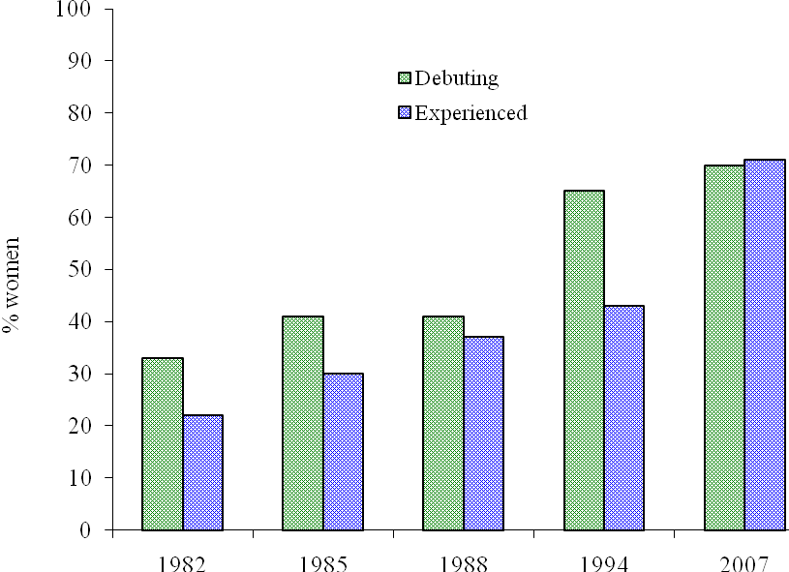
Figure 2: Proportion of women among newly appointed school leaders without (green color) respectively with earlier experience as school leader (blue color).

The results of the 1990s, however, showed that the kommun politicians’ trust of women as school leaders once again took off. Among the school leaders that local politicians appointed in 1994 that had earlier experience as a school leader 43 % were women. Among the debuting school leaders that were appointed in 1994, 65% were women. In 2007 there is even larger proportion of women who are appointed as school leaders, both among the debuting ones (71%) as among those with previous experience (71%). School superintendents and local politicians who are responsible for the appointment of school leaders have turned vision during the last thirty years in terms of who should be eligible for school leadership. Nowadays women are preferred to men.
The previous differences in the pattern of appointments of school leaders that was found between the grund schools and the gymnasie schools consist in the 2000s. In 1994 57% of the reported school leader posts that got new holders got a woman. In the gymnasie schools that year 42% of post got a woman as holder. In 2007 there is 50% of the new holders of a post as school leader in the gymnasie school who are women and in the grund school there are 77%.
Being a school leader - today a profession for women
The development during the past 40 years shows that women are increasingly accepted and appointed as school leaders. In Sweden the school leader profession has largely become a profession for women. The aim that the government (Prop 1987/88: 105) set at the mid-eighties in the bill on gender equality policy for the 1990's has been achieved by a wide margin. At that occasion the government set as a target that 20% of rektors and 30% of studierektors would be women in 1993. According to statistics published by Skolverket (the National Agency for Education) for 2007 59% of the school leaders in the public schools were women. Within the grund schools women dominate in school leader positions (64%) while they are in a minority (42%) in the gymnasie schools. If this change of the school leader profession has led to a professional appearance that will become more feminine than masculine can possibly be inferred from an interview study that Franzen (2006) made in the early 2000s. The long term trend reported in this study shows that a traditionally reverse inequality has emerged between the genders when it comes to school leader work in grund schools. If the job should be a profession for both men and women and whether schools can meet the requirements for them to act in exemplary ways in terms of gender, it now appears to be necessary to provide support and encouragement to men to become school leaders in grund schools, at least in some regions of the country, in the same way that happened to women during 1980s.

Regional variations in patterns of recruitment

Large regional differences existed in the late 1970s in terms of the proportion of women among the school leaders. In some parts of the country the kommun politicians and the county school boards' officials showed distrust of women in leadership positions. In 1978, there were no women as school leaders in half of Sweden's kommuns. Regional streams of values and different traditions had evolved in different counties, which made its mark on recruitment of school leaders. In Stockholm County, for example, the proportion of women in school leadership positions in 1978 was the highest in the country by a quarter of all school leaders. In the region of Värmland, women accounted for only 6% of school leaders. Appointments of women as school leaders in different counties reflected largely a stable pattern. Although the rate of women appointed as school leaders fluctuated over the years for many counties, certain basic patterns persisted for quite some time. The development during the 1980s showed that the kommun politicians in counties which in 1978 had a high proportion of women continued to be more daring to invest in women among the newly appointed school leaders than they did in the counties which in 1978 had a lower proportion of women. According to Statistics Sweden, 55% of school leaders were women in Stockholm County in 1994, while women accounted for 23% among the school leaders in the county of Värmland in the same year. The fact that the kommun politicians situated in past women hesitant regions responded to public pressure that existed and knew of the changed norm winds, however, proved in the 1994 data (see Annex 2 for an overview of the counties at the various years of studies). The counties that previously choose women as school leaders among applicants with no experiences in the profession at the lowest level now gave priority to women to a higher degree than others. Uppsala County (county C in Annex 2) is one example. In the mid-eighties and in 1987 and 1988 only women were chosen for positions as school leaders among the debuting applicants.
A calculation of the correlations between different years of how often women are chosen as school leaders in different parts of the country have been made using Spearman's rank correlation (Siegel, 1956) for both appointments of experienced and debuting school leaders. Coefficients of correlations are shown in Annex 2. It turns out that there are no clear patterns of how kommun politicians in different parts of the country choose to appoint women as school leaders over the years studied. The correlations are not statistical significance. Over the years, the similarities between different parts of the country have grown.
In order to show what changes have been going on in the pattern of appointing women as school leaders in the four counties that had rather separate patterns of appointments in the 1980s we present the statistics from 1994 and 2007. According to statistics from Statistics Sweden, in 1994 the largest proportion of women as school leaders appeared in the county of Stockholm (AB on the map of Sweden on page 14) with 55%, followed by the county of Östergötland (E on the map) with 45%. The two counties which had the lowest proportion of women as school leaders were Värmland (S on the map) and Skaraborg (parts of O on the map) by 23%. Figure 3 and 4 shows the changes that passed from the early 1980s through 1994 until 2007 in the four regions in the proportions of women appointed without earlier experience of school leader work and among those with such experiences.

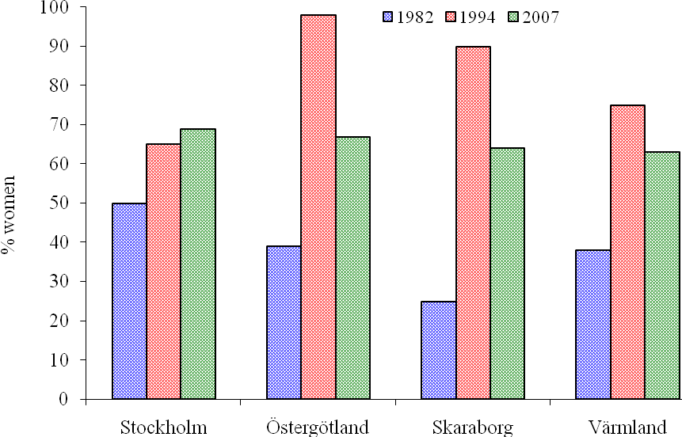

Figure 3: Proportion of women among newly appointed school leaders that make their debut in the profession in 1980s, 1990s and in 2000s in four Swedish regions.

The graph shows that in 1994, compared with twelve years earlier effort was strong on appointing women in school leader positions in the two counties with the lowest proportions of women. In Värmland, three-quarters of the debuting school leaders were female and in the region of Skaraborg females were chosen in nine out of ten school leader appointments. The public debate, that took place the years that followed after that the state committee had presented its analysis and noticed that there was a need for women as school leaders, had strong repercussions in the local discussions on whom to appoint as a school leader. In Stockholm County there were already at the beginning of the 1980s a tradition to appoint women as school leaders and the trend continued in the mid 1990s, where 65% of the appointments among school leaders who made their debut consist of women. In 1994 the reported appointments where debuting school leaders were selected in the county of Östergötland women were considered in all cases. When the study began these four regions had distinct different patterns of recruiting women as school leaders. In 2007 the differences are completely wiped out. No matter where in the country you are, school superintendents and politicians are willing to invest in women when they appoint a debuting school leader. In all these four parts of the country the local politicians choose to appoint more women than men as school leaders when they opted for a candidate who lacks experience in the school leader profession.

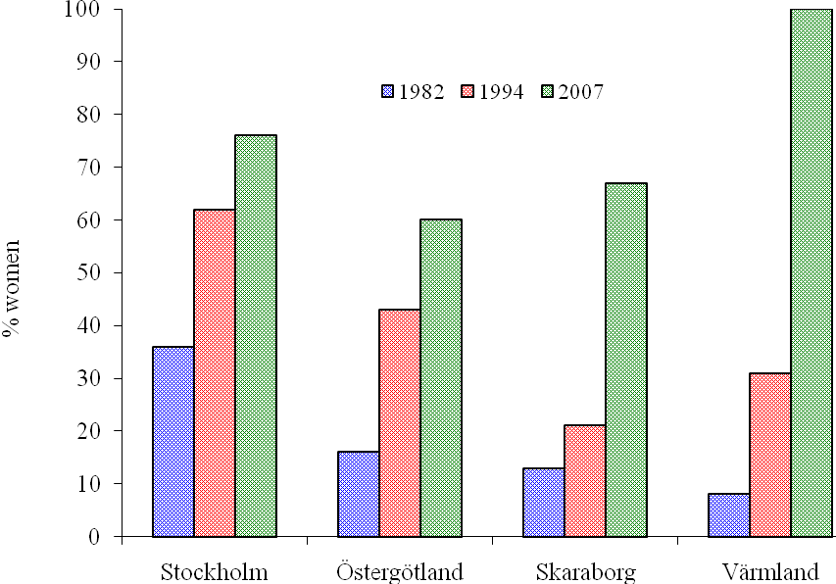

Figure 4: Proportion of women among newly appointed school leaders that have earlier experience as a school leader in 1980s, 1990s and in 2000s in four Swedish regions.

In Stockholm County women's share of school leadership corps increased at a steady rate during 1980s, 1990s and during the 2000s as a result of the early focus on getting more female debuting school leaders in place. More women had a chance to gain experience as a school leader and could also seek new positions. The kommuns in counties that before and during the 1980s had been slower to develop the courage to invest in women as school leaders had in this decade and in the 1990's harder to be able to appoint women with school leader experience, because so few women had this kind of positions. As the new century began regions with low frequencies of female school leaders came up with the other regions. In these regions the decision makers continue to appoint women as school leaders to a large proportion even when they have chosen leaders with experience in school leadership. In the new millennium the politicians choose to fill vacant positions with applicants who have experience as school leaders and they act in all parts of the country in the same way as one prefer women instead of men as school leaders. The uniformity that existed over the kommuns in the more centralized school system of Sweden reflected in the early 1980s, resulted in the selection of men as school leaders. According to the political rhetoric the country at the end of the first decade of the new century is characterized of a strong decentralization within the system of education. Nevertheless, the survey shows that a strong uniformity again prevails in the kommuns. However at this moment Sweden lives with a reverse pattern of choice of who to appoint as a school leader. School managers and politicians prefer women before men in such positions.

Variations between kommuns of different size

In Sweden it is local politicians who decide on who gets a school leader post. The pattern of recruitment that is reflected in this study are results of the processing work among civil servants in the school administrations and of the decisions made by the local politicians.
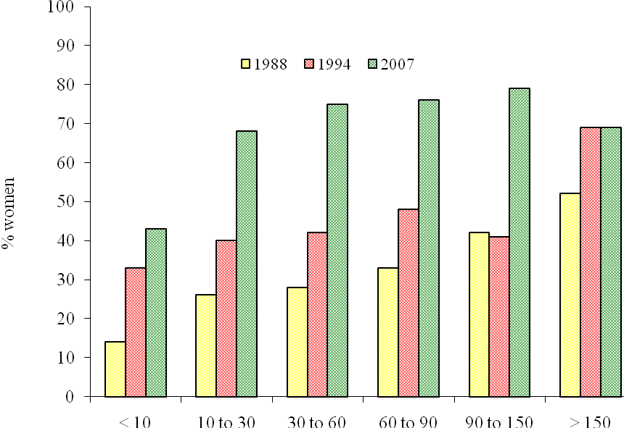
Figure 5: Proportions of women among newly appointed school leaders that have earlier experience as a school leader in 1980s, 1990s and in 2000s in kommuns of different sizes. The kommuns are grouped in six different sizes, from less than 10 000 inhabitants to those with more than 150 000 inhabitants.

In order to illuminate how municipalities of different sizes have invested in women as school leaders, materials from 1987/88, 1994 and 2007 were compared. The material from 1987/88 is described as 1988 to facilitate the presentation.
Figure 5 shows that the dominant pattern to give school leader posts to men with professional experience was not totally uniform among the decision makers in the kommuns in 1988. A correlation existed between the size of the kommun and the willingness to choose a female applicant with earlier experience for a post as school leaders. The smaller the kommun, the greater was the chance for a man with earlier school leader experience to be appointed. This pattern of correlation weakened in the 1990s, when it becomes more common in kommuns of all sizes that more women with professional experience will also be considered for the vacant position. When the new century has had time to establish also the new uniformity to choose women as school leaders has grown in all kommun sizes except among the kommuns that are the smallest. It is only among those kommuns that the decision makers do not prefer women with school leader experience before men with the same experience when new appointments are made. As shown in Figure 6, where the appointments made by people who lacked experience in school leadership profession is reflected, the new coherence to choose women as school leaders had an impact on all kommun sizes.
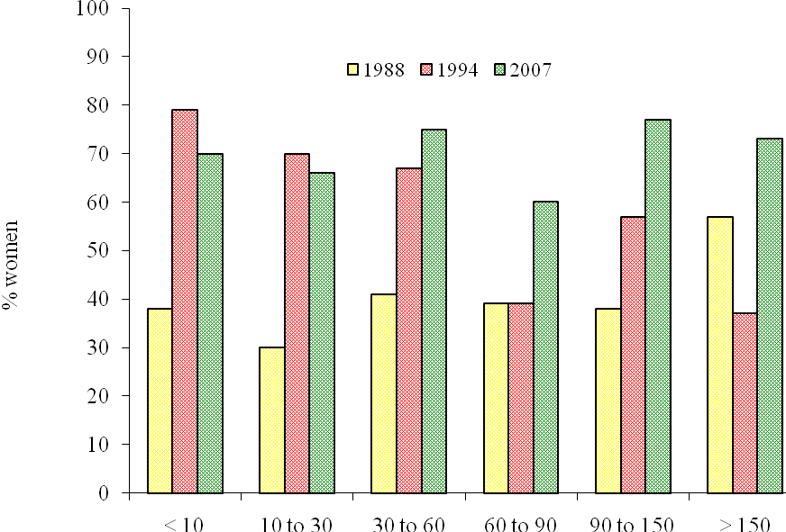
Figure 6: Proportions of women among newly appointed school leaders that have no earlier experience as a school leader in 1980s, 1990s and in 2000s in kommuns of different sizes. The kommuns are grouped in six different sizes, from less than 10 000 inhabitants to those with more than 150 000 inhabitants.

The clear correlation between the size of the kommun and the appointment of men as school leaders that appeared in the statistics of 1980s for the school leader experienced candidates that were chosen, to a smaller degree was reflected for the positions that were filled with candidates without that professional experience. During the 1990s, the smaller kommuns, stimulated by the public debate, took a big leap towards daring to choose women as new school leaders. In 1994 there is almost an inverse relationship to the size of the kommun compared with the past – the smaller the kommun, the higher the chance for a woman without a school leadership experience to qualify for a school leader post. When the last data collection was made the tendency of correlation between kommun size and choice of different gender for school leader positions has fallen away. Kommuns of all sizes act more streamlined as they mainly prefer to fill a vacant school leader post with a woman who debuts in the school leader profession than with a man.
That some of the smaller kommuns during the 1980s not succeeded to live up to the political ambitions cannot be explained by referring to that the ambition is impossible to realize as they actually were realized in kommuns of larger size. The reasons for this lack of fidelity to the commission given to the kommuns by the parliament and the government may instead be sought in the greater proximity of the politician in the small kommun and the users of the school. When you have more frequent contact with those who work in the school, the rich information from work-mates on internal candidates easier win support than the more brief information, that can be obtained about applicants that come more from a distance. Put another way - the risk of peer corruption in the appointment of school leaders are increasing in smaller kommuns, which is the reason why the traditional selection criteria have been easier to gain support and linger there. This pattern was particularly valid for those appointments where professional experienced school leaders were chosen. When one dared to go for inexperienced applicants the trend towards single-gender choice in kommuns of different sizes was decreased.

Chapter 5. Educational and professional background of new school leaders

Until 1.1.1991 it was stated in the School regulation who was allowed to work as a school leader. In chapter 12, §6 it was written:
"As rektor or studierektor is a person qualified that is qualified for a regular position as teacher in the kind of school that the school leader position is placed in. If extreme reasons exist, a person that is not qualified for a regular position as a teacher may be appointed as school leader. ".

The changed Law of Schools opened for other groups than teachers to apply for a position as school leader. It states
" As a leader for the education given at a school there shall be rektors. The rektor shall be thoroughly knowledgeable about the daily work in the school. The rektor especially is responsible for the development of the education. As a rektor only a person that through education or experience has conquered pedagogical insights can be appointed.." (Skollagen, chap 2, 2§).

Reorganizations within the kommuns, which has included the merge of units responsible for both schools and child care, have in recent years in many kommuns brought in school leaders with experience from preschools as well as from leisure activities of the kommuns. Today as in the past, the national curricula and the school regulations reflect the expectations of the state and of the kommuns on school leaders. 1980s were characterized by various changes in the responsibilities of schools, which have led to more and clearer requirements on school leaders. As a consequence of the changed control system of the school with other responsibility relationship between state level and kommun level, the role of the school leader has changed. Reorganizations of the kommuns have in many cases led to school leader positions with more areas of responsibility than before. The recruitment process has become a more important part in the efforts to find the right candidates for the posts advertised.

Who became a school leader in 1978? The largest statistical probability to become a school leader had a male subject teacher working with students from grade 7 to 9 in the grund school. At that time one out of five male subject teachers in grund school became school leaders. Those with the next highest probability to become a school leader, one out of seven, were male subject teachers in gymnasie schools together with male teachers that were teaching students of grade 4 to 6 in grund school. Among women, about one out of fifty among subject teachers working either at a grund school or at a gymnasie school qualified for the leadership position as school leader. If the female teacher worked with students in grade 4 to 6 in a grund school the probability to become a school leader during the career was 1 to 153. The probability was even lower for a female teacher teaching the youngest children in the grund school (grade 1 to 3) to become a school leader – one chance in 445 (SOU 1980:19). The next two tables show which teacher categories among males and females that became school leaders in grund schools and in gymnasie schools during the eighties until the mid-nineties.

New professions as background among school leaders
The movements that existed in the 1980s in terms of what background you had before you were appointed as school leader were small. It became a little more common to choose females that were experienced as school leaders and that had a background as teachers for grade 4 to 6 in the grund school or as teachers in a practical subject in the gymnasie school.
Table 5. Background of newly appointed school leaders 1981 - 1994. Proportion among male and female teachers with earlier experience as school leaders.
Men Women
 | 81+82 | 85 | 87+88 | 94 | 81+82 | 85 | 87+88 | 94
Grade 1-3 in grund school | 0 | 1 | 0 | 0 | 20 | 20 | 17 | 26
Grade 4-6 in grund school | 31 | 25 | 22 | 43 | 20 | 18 | 31 | 29
Subject teacher | 58 | 55 | 59 | 44 | 43 | 30 | 20 | 25
Practical subject teacher | 5 | 11 | 9 | 8 | 1 | 5 | 10 | 9
Special education teacher | 6 | 8 | 11 | 3 | 15 | 26 | 21 | 3
Preschool/Leisure time | 0 | 0 | 0 | 2 | 0 | 0 | 0 | 8

During the 1980s it also became less common in the grund school to appoint experienced male school leaders that had been teaching grade 4 to 6 students in the grund school. The female school leaders were recruited from several different categories of teachers than men were. 1994 the pattern of recruitment had changed. Among experienced male school leaders at that time a background as a teacher for 4 to 6 graders was preferred to a larger extent than a background as subject teacher for 7 to 9 graders of the grund school. Among women that had experienced being a school leader that got a new position those that had a background as teachers for grade 1 to 3, grade 4 to 6 or being a subject teacher were preferred. During the eighties, it became increasingly common for both men and women with earlier experience of being a school leader that also had a background as special education teacher to get a new position. In 1994, it was only a small percentage among both men and women who had that background. In 1994 other than those that had a traditional teacher background and had experienced being a school leader entered. 8% of women that already had experienced being a school leader and was chosen for a new job had a background in childcare and leisure time activities. Among those appointed that had earlier experience as a school leader a smaller group was experienced in other professions than the teacher profession, such as social workers and civil engineers.

When the kommuns in the 1980s invested in school leaders without earlier experience in the profession, men with a background as subject teachers were more seldom chosen and women with a background as special education teachers or teachers of grade 4 to 6 were more often chosen
Table 6. Background of newly appointed school leaders 1981 - 1994. Proportion among male and female teachers without earlier experience as school leaders.
Men Women
 | 81+82 | 85 | 87+88 | 94 | 81+82 | 85 | 87+88 | 94
Grade 1-3 in grund school | 0 | 2 | 1 | 1 | 26 | 19 | 17 | 7
Grade 4-6 in grund school | 32 | 33 | 36 | 49 | 19 | 26 | 29 | 9
Subject teacher | 55 | 50 | 43 | 18 | 30 | 22 | 30 | 8
Practical subject teacher | 8 | 9 | 10 | 1 | 11 | 14 | 4 | 3
Special education teacher | 6 | 6 | 10 | 2 | 14 | 19 | 20 | 3
Preschool/Leisure time | 0 | 0 | 0 | 27 | 0 | 0 | 0 | 69

It became less common to invest in debutantes with a background as a teacher for grade 1 to 3. The campaign that was conducted by the State in the early 1980s, that would encourage women to apply for school leader positions, and that also took aim at stimulating the teachers with such a teaching background who were poorly represented in the profession of school leaders to seek services, seems to have given a " surge "in the appointment pattern, but this appears to have leveled off around mid-decade. The proportion of teachers of special education and teachers for grade 1 to 3 who become school leaders in primary stops or reduces among the debuting school leaders. However, it is subject teacher background, which dominates among the teachers selected as school leaders during the 1980s.

Even in the case of the debuting school leaders the recruitment pattern was different in 1994 compared with previous opportunities to measure. School leaders with the background in childcare and leisure time activities dominated among the newly appointed school leaders without previous experience of the profession. Among the debuting women it was seven out of ten who had experience in childcare and leisure time activities and among debuting men, it was more than one in four with this background. Among male debutants it was more frequent than in the past that one would have been a teacher for 4 to 6 graders.

The results reported on the background of the school leaders that were appointed 1994 show that some traditional patterns have been broken. The alterations reflect some of the value changes that occurred at that time among civil servants and politicians that were involved in the selection processes of new school leaders. The development from the early 1980s also shows that individuals with another background than the traditional teacher background started to be accepted as a person competent for a job as school leader. Structural changes in the way kommuns organize the inner work have led to that more school leaders are retrieved from the area of childcare and leisure time activities. 70 % of the school leader positions that found new holders in 1994 became responsible not only for ground schools but also for childcare and leisure time activities. When the kommuns chose new school leaders they were eager to use experiences that the applicants had made also in these working areas.

This is one of the reasons why there are so many women that are chosen as school leaders in 1994. In this study we have chosen to categorize new school leaders that have not held leader responsibilities in schools as debuting school leaders. However some of the persons within this category in 1994 have had experience as leaders, but not for schools, but for child care or for leisure time activities. We do not know how large experience to lead a preschool or a unit of leisure time activities these persons have as we never asked for that kind of information in the 1994 survey.

Among those chosen as school leaders in 1994 in the gymnasie school a background as subject teacher or as practical subject teacher dominated. Among those that debuted as school leader the proportion that had a background as subject teachers grew in 1994 compared with earlier in relation to those with a background as practical subject teachers. This pattern has strengthened even more when we look at the situation in 2007. 53 % of those that made a debut as school leader in the gymnasie school that year had a background as subject teacher compared to 15 % with a background as practical subject teachers. In 1994 10 % of the new appointed and debuting school leaders in the gymnasie school had a background as vocational guidance officers and 7 % of them had another background than teachers or vocational guidance officers, like for instance military service personnel, psychologist, social worker, civil engineer, journalist. In 2007 none of the new school leaders that made debut in the profession were earlier vocational guidance officers while 17 % had another professional background than being a teacher.

Table 7. Debuting school leaders 2007 (N=219). Professional background among women (N=159) and men (N=60). Percentage of debuting within each gender group.

Professional background | Women | Men
Preschool teacher | 21 | 3
Leisure time pedagog | 5 | 7
Teacher for grade 1 to 3 in grund school | 3 | 0
Teacher for grade 4 to 6 in grund school | 8 | 5
Teacher for grade 1 to 6 in grund school | 11 | 8
Teacher for grade 4 to 9 in grund school | 10 | 28
Special education teacher | 7 | 2
Subject teacher | 21 | 20
Professional instructor | 3 | 7
Practical subject teacher | 3 | 2
Vocational guidance officer | 2 | 3
Military service man | 2 | 10
Behavior scientist | 2 | 0
Social worker | 0 | 2
Other | 3 | 3

Table 7 shows the professional background of females and males for all kinds of schools kept together. The dominating background among women as well as among men is to have been a teacher. What kind of teacher you have been before becoming a school leader differs between the gender groups. More women than men among those making a debut in the school leader job have a background working with learning and development among younger children. It is less common in both groups that a new school leader has a background as practical subject teacher or as a professional instructor. It is more common among men than among women to have another professional background than being a teacher.

You know what you have ….

During 1970s and 1980s a strong norm existed among politicians in the kommuns that prescribed that it was suitable to choose a person for a position as school leader from people already living in the kommun and also to choose someone that had been working as a teacher for a while in the school that the school leader would be responsible for. In figure 7 the decline of the strength of this norm during the last twenty five years is shown.

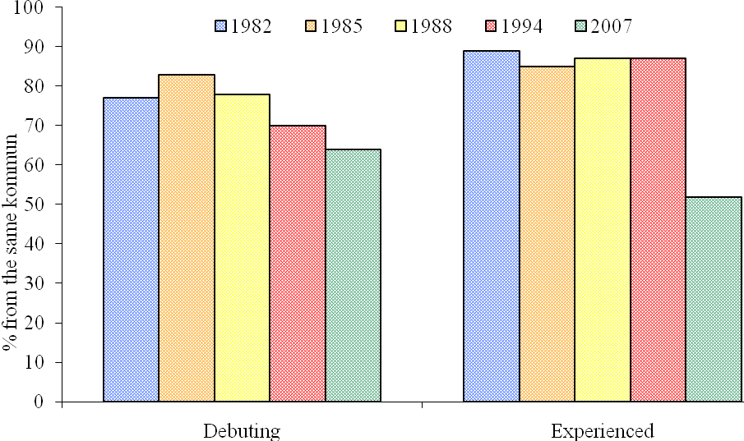
Figure 7. Percentage among new school leaders with and without earlier experience working as a school leader that has got a school leader position in the kommun where they already were working.

The earlier very stable recruitment pattern, which applicants coming from the local kommun were chosen ahead of someone coming from another kommun, is slowly disappearing. During the three decades that has been followed it is a substantial part of the appointed school leaders that have been chosen from the same kommun as the free position exists in. However the tendency to choose someone from your own kommun is shrinking, both when a school leader is chosen among persons that already have worked as school leaders or when one choose a debutant. Among the 243 debuting school leaders that were chosen for a job in 2007 almost two out of three were coming from their own kommun. Among the 412 persons that already were experienced school leaders that were chosen for a new position it was less than half that came from the same kommun as the free post were placed in. Most of those that have been selected to fill a free school leader position have a background working in the same kind of school as they take the leadership of. Some examples exist of people changing for instance from having worked in a gymnasie school and becoming a school leader in a grund school, but these examples are rare.

There are some clear differences over the years from what school the new school leaders were taken from. During the 1980s there were about seven out of ten among the debuting school leaders that were taken from the same school as the school leader post that they received were placed. They became leaders of their previous mates. In 1994 this pattern almost had been reversed. Only one out of four among the debuting school leaders was employed as school leaders in the same school where they had been working as a teacher. This frequency is repeated in the 2007 study. This new appointment pattern that decision makers have followed since the mid nineties where they avoid to put someone in command of earlier mates seems to have come to stay. The decision makers have taken up the main drawbacks that might raise when you chose to put someone in charge as a manager that earlier have had a position as teacher in a school.

In the 2000s it becomes more common that the kommuns take school leaders from aschool in another kommun than their own and also chose people coming from other organizations than schools. Among the persons that were chosen for school leader positions in 2007 there are examples of those that have worked within university, university colleges, military services, publishing companies and from different production or selling companies. Most of the individuals with this experiential background also have a basic training as teachers. A larger proportion among those that received a school leader position that had earlier school leader experience than those that were debutants comes from another place than the kommun of their own. In 2007 it is a little less than half of the more experienced ones that are finding a school leader post in another kommun than in their own but almost two out of three of the debuting school leaders that find a school leader post in the kommun of their own. No significant differences are found for the genders with respect to in what kommun or what school that they have had their earlier position. Figure 8 and 9 show how large proportions of the new school leaders that have been taken from the same school and from the same kommun in which they will work as school leaders in kommuns of different sizes over the years.

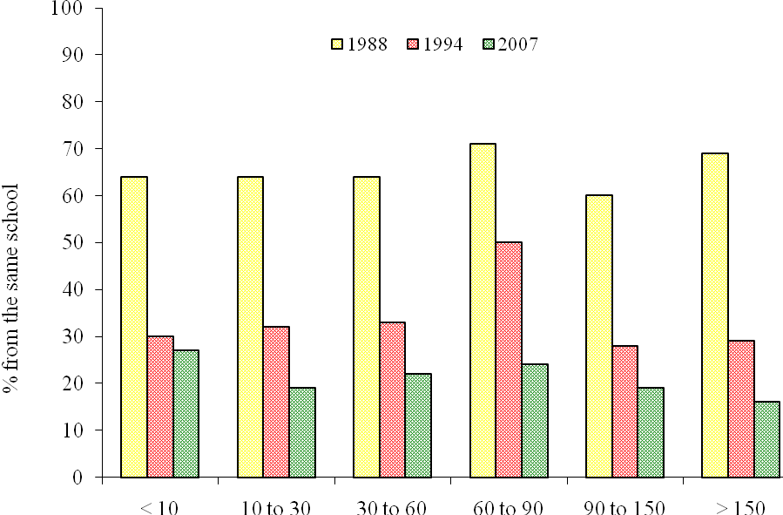

Figure 8. Percentage among new school leaders that has got a school leader position in the same school where they already were working during three decades. The kommuns are grouped after number of inhabitants from less than 10 000 inhabitants to those with more than 150 000 inhabitants.

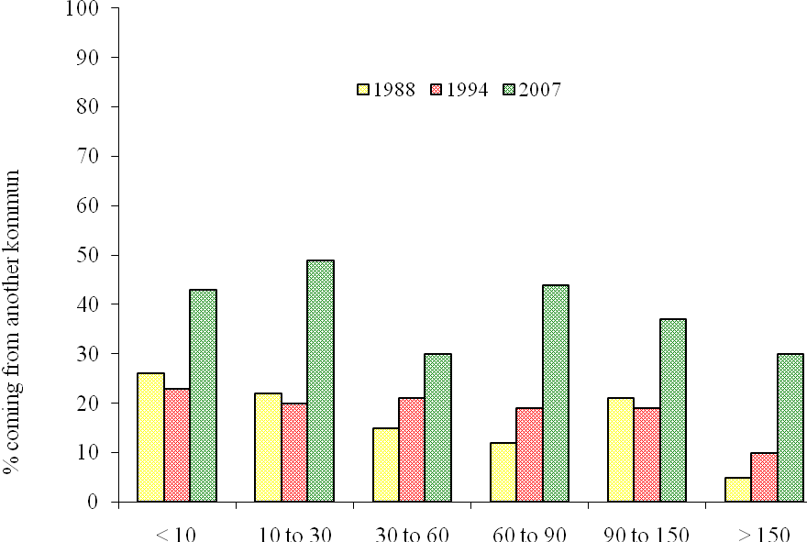
Figure 9. Percentage among new school leaders that has got a school leader position in another kommun than the one where they already were working during three decades. The kommuns are grouped after number of inhabitants from less than 10 000 inhabitants to those with more than 150 000 inhabitants.

Regardless size of the kommuns the idea of appointing a school leader that comes from another work place than the actual school has been accepted in 2007. The pattern that earlier existed – to appoint a teacher of the actual school as a school leader there – has almost disappeared. By choosing someone as school leader that comes from another school the politicians of the kommuns have made it possible for the new holders to design a leadership that is not burden by old mate relationships of the local school. The geographical mobility among those that have been selected as new school leaders has increased during the decade. It is between forty to fifty percentage of those who are appointed as school leaders in kommuns of the sizes up to 30 000 inhabitants and in the interval 60 000 to 90 000 inhabitants that come from another kommun. In the largest kommuns and in the kommuns in the interval 30 000 inhabitants to 60 000 inhabitants it is only about one out of three school leaders that are taken from another kommun than their own.

Number of applicants and the education of new school leaders

In the 2007 survey some new items were included that had not been involved in the earlier questionnaires that had been used in the 1980s and 1990s. The new questions concerned what numbers of applicants there were on each free school leader position, what kind of leadership training or leadership education that the applicants that got a new job had and what kind of induction training the new school leaders got when they were accepted for the new job. Out of the 655 school leader positions that were given new holders in 2007 we received information for 569 on how many applicants there had been from the kommuns. Some of the reasons that the kommuns gave us why no information was given was that the kommun did not want to give out that kind of information or that they had lost that information at the time when we asked. The numbers of applicants on the 569 free school leader positions that we got information about are shown in table 10.

Table 10. Number of applicants for 569 free positions as school leaders in Swedish kommuns in 2007.

Number of applicants
 | 1-3 | 4-6 | 7-9 | 10-12 | 13-15 | 16-18 | 19-21 | 22-24 | 25-27 | 28-30 | > 30
Number of free school leader positions  (N=569) | 58 | 62 | 53 | 93 | 58 | 43 | 56 | 27 | 31 | 23 | 65

Among the 65 positions that had more than 30 applicants the questionnaire did not catch the true situation at the application deadline. In some of the kommuns that belong to this category all school leader positions were announced as free because the kommun was reorganizing. When answering our survey the kommun has mentioned everyone that has applied for all the positions in the kommun for all of the free positions. This kind of systematic error in the information given for other school leader posts that were free cannot be detected for other answers given. As can be seen the number of applicants for each free position is large in the Swedish context. Calculating an average on basis of the free positions that have up to thirty applications (leaving the last category where a measurement error exists) there shows to be thirteen applicants on each free school leader position. Seen with international eyes Sweden shows a positive deviation from an international trend. Fifteen out of twenty two countries reported at this time problems to get enough applicants to choose among for school leader jobs (Pont, Nusche and Moorman, 2008, p. 129).

In table 11 the experience of those that were appointed as school leaders is related to what kind of leadership training or leadership education that they had.
Table 11. Earlier experience of being a school leader before receiving a new position related to what kind of leadership training or leadership education one has gone through. (Information is lacking for 45 out of 655 new school leaders).

Years as school leader.
Leadership training or education | 0 | 1-2 | 3-4 | > 5 | Sum
School leader education, national program | 19 | 4 | 29 | 128 | 180
Leadership courses at a university | 24 | 18 | 8 | 9 | 59
Other leadership training | 87 | 59 | 16 | 38 | 200
No leadership training or education | 85 | 52 | 18 | 16 | 171
Sum | 215 | 133 | 71 | 191 | 610

Four out of ten of those that were appointed as school leaders in 2007 had three years or longer experience of being a school leader. Of those appointed as school leaders there are only one out of ten that lacks some kind of leadership training or leadership education. Out of those with less than three years of experience as school leaders, two out of five lack education or training as a preparation for the leadership task.

Chapter 6. Some reflections

Since the number of school leader positions grow significantly in the beginning of 1960`s in Sweden the way to a school leader position followed a relatively stable pattern. A school leader at place that needed to be temporarily replaced asked one of the teachers of the local school to jump in. The criteria for asking someone at the school to act as a substitute was shifting between the different school leaders that needed to be replaced. The first replacement periods usually was rather short in time, but when the substituting teacher had jumped in several times it usually opened for a longer period as school leader substitute. To have had earlier experience acting as a school leader became an important merit for teachers that wanted to become school leaders. The shorter or longer period when a teacher was acting as a school leader was seldom a part of a career plan of the kind that is used in business or industry. In such organizations it is common that leaders elucidate the ambitions of management trainees and that a career plan for the trainee is drawn up. This routine have helped many trainees to make up their minds about becoming a leader, but also made it possible for the manager in charge to form an opinion on the candidates.

In the world of schools the school leader substitute many times had to act in another way. They really jumped into the job as a school leader without previous preparation or discussions about ambitions. They were expected immediately to fill the role as school leader. Another way into the work as a school leader was to work out next years working schedule of the school. This task was usually conducted during the summer vacations to prepare the division of work among the teachers before the new school year begun. In Sweden, this way to let willing teachers into the job of school leaders has changed during the last two decades. In most kommuns school leaders hold performance reviews with the staff, where among other themes future plans and career steps are discussed. In many Swedish kommuns aspirants of school leadership have been asked to try a more limited leadership task to make their own judgment of the job. Instead of substituting as a full school leader the aspirant has had a possibility to concentrate on a limited area of school leader work like for instance planning in-service training for the teachers, to manage the use of ICT at the school or to draw up the resource needs of the school with a longer perspective.

Education as stimulation

During the 1980s more and more kommuns have started to use recruitment educations as an instrument for school leader aspirants to become accustomed with the work of school leaders. They have also used this kind of activities to have a chance to review the qualities of the school leader aspirants to be able to act as a school leader. During the 1980s the state stimulated the kommuns to use study circles combined with periods of field studies of the work of a school leader to motivate school staff to apply for a position as school leader. The study circles especially addressed to groups of teachers that seldom became school leaders, like teachers for grade 1 to 3 of the grund school and female teachers at large in all kinds of schools. Judging from our studies these study circles had small and limited effects on the recruitment pattern. There were not more women appointed as school leaders, there were not more young people appointed and there were not more often that teachers with another background than the traditional were chosen as school leaders during 1980s. The study circles may of course have had some other kind of effects as applicants may have made more conscious choice to join the school leader profession as they had better possibilities to learn what expectations there were on school leaders. It is also possible that the applicants became more well known by the people responsible for the selection in the kommuns which may have led to better informed decisions. And it is also possible that the appearance of study circles of school leadership made it more accepted among teachers to apply for a position as school leader.

The recruitment education arrangements usually were turned into the local kommun which made them ineffective to stimulate a more mobile recruitment pattern. During the 1980s there was no tendency that kommuns choose applicants from other kommuns when they appointed someone as school leader. Other means were needed to break the stable patterns of school leader recruitment that existed during the 1980s.

Changes that affects

Sweden went through large structural changes of its school system in the end of 1980s and during the first half of 1990s. Among other things hiring and firing of teachers and school leaders fully went over to the kommuns from the state. The kommuns got much larger power over the way in which schools and child care was organized. Child care, leisure time activities and schools have fallen under the same political governing bodies in many kommuns. Today it is not unusual that a school leader is responsible not only for teachers and the education of students but also for child care and leisure time activities. In the study that we made in 1994 we saw evident traces of these changes in the way school leader recruitment was developed. A new category of applicants to school leader posts with a background in child care and leisure time activities were chosen for school leader jobs. This helped the traditional pattern of recruitment of school leaders to be broken.

What happened when new categories came in as school leaders? In connection with an evaluation study in a Swedish kommun Scherp (1996) constructed an index of pedagogical change that he related to the kind of school leader that managed the school. He found that the degree of change varied with the background of the school leader. In schools where the school leader had a background in child care and leisure time activities the teachers estimated the change as larger than teachers working under school leaders that shared their own background. Although the reason for change may not be the different background of the school leader the study showed that such a background at least does not hinder pedagogical development. In this evaluation study also other patterns showed up. Teachers who had changed their working pattern to a larger degree were found in schools with a school leader with a back ground in child care and leisure time activities. In this study teachers also changed their way to work to a larger degree in schools where a woman was theschool leader.

School leaders and politicians decide who will become a school leader

The stable pattern of recruitment that has been found over the years in Sweden does not at large depend on the behaviors of the people that apply for a position. At large it is produced by actions and thoughts that are kept by those who are responsible for the decisions taken in the recruitment chain. The school leaders that are at work are the first one that acts in this chain of events. They are the ones that take the first decision to persuade someone in the school to grips with a more or less limited task of leadership. In Swedish schools the local school leaders together with representatives of the unions have chosen some people as leaders of teaching units or working units in the preschool or the leisure time activities. Some of the teachers in modern schools may have spent a substantial time as a leader of this kind of work at the school and thereby become well acquainted with parts of the school leader work.

At schools where the task to lead a working team involves several leading tasks this work is a good preparation for a larger responsibility that lies in the role of the school leader. In many schools there are difficulties to recruit teachers as working team leaders mainly because the task involves leading of mates. As in business and industry where there sometimes have been problems to recruit workers to act as supervisors of work mates a socio psychological mechanism is here reflected. To be a good work mate and share good fellowship is more attractive for most people than to shoulder a leading position in relation to the work mates and thereby automatically being forced to stay aside the fellowship.

However in some schools the way one deals with leadership in working teams does not prepare for a wider school leadership. The task to act as a leader in the working team has become so limited that it does not imply a real leadership. The local culture of the teachers hinders a colleague to act as a leader of colleagues. No clear initiatives are allowed from the local working team leader. He or she is reduced to serve the others in the working team so that their working conditions are good. In such school the working team may stay as a formal organizational unit that keep a couple of meetings each year to fulfill some formal demands but is not a real working unit with an accepted leadership. The teacher who takes a leading role in such a school often needs to accept several humoristic diversionary comments that is used to protect the working unit from the leadership.

In such schools leadership is somewhat of a taboo. A kind of an equalizing and oppressing law is working on the staff of these schools that prescribes that the one that is brave enough to raise the head above the others immediately is pressed down to the level of the others. If the kommun together with the state will be able to succeed in overcoming the paralysis that exists in many schools one need to open up the work climate of the schools, to drive open discussions about leadership at the schools and to challenge the people at the schools to be brave enough to shoulder leadership tasks. Of course the employer needs to give clear signals that one wants to have a good leadership at the schools. One way to show this clear signal is to pay school leaders well. It also seems to be important that politicians of the kommuns, and especially those working in smaller kommuns, challenge their own recruitment patterns so that they more often choose competence coming from other kommuns and schools than the one where the positions are free.

Weakness that are disappearing

The stable pattern of school leader recruitment that existed during 1970s and 1980s contained some weaknesses that cried for changes. Most serious was the tendency to kommun based and school based “inbreeding” – that the decision makers mainly choose someone from the school where a position as school leader was free. This kind of “inbreeding” weakens the school leadership more than necessary. The one that is a mate in a group of teacher is seldom accepted as a school leader over a night. When someone is appointed to lead a school where all the old colleagues are the working community the leadership is maximum difficult to conquer. From 1994 and onwards this pattern of recruitment have been broken. That this has been done has led to a step to create a more fresh school leadership in contemporary schools.

Local politicians of the kommuns have large power in the process of recruitment of new school leaders. Before 1990 their way to handle the power more dealt with pleasing the staff of the local school so that they could get a colleague as school leader. A colleague that acted in such a way that the teachers know where they had him and one that they could trust to nurture the existing culture and not threatening the status quo. A colleague that not challenged the local school culture and for instance put demands on the teachers to follow central guidelines like using more varied working methods or to build the educational process on the participation of the students. Based on the outcomes of the studies we made in 1994 and in 2007 the politicians of the kommuns nowadays seem to take their task more seriously so that they show the professionals working in schools that the ideas that they have based their decisions on about schools and schooling are for real.

The scalability of the School Leader Education

The study that we made in 2007 of the school leader recruitment patterns in Swedish schools occurred while a new version of the nationwide School Leader Education (Ekholm, 2007) was created. The National Agency for School Improvement in 2006 estimated that there would be a need for about 1 200 places of education in the School Leader Education so that all new school leaders that one expected the kommuns to recruit could be guaranteed a place. A state committee followed up the prognosis that the national agency had presented and raised the expected figures from 1 200 to 1 400 as the agency not had calculated with leaders within the preschools that the kommuns would appoint. The calculation of costs for the new version of the School Leader Education was based on these estimations. The government therefore raised the earlier yearly financial allocation for School Leader Education from around 5,5 million € to about 11 million €.

The estimates that were made of how many newly appointed school leaders that needed to participate in the School Leader Education programme was to a small degree supported by the empirical material that we created through our survey among the kommuns. 95 % of the kommuns answered our questions in 2007 about newly appointed school leaders. In the answers that the kommuns gave we sometimes find appointments of leaders of preschools, sometimes this information is not found in our material. We therefore have assumed that we have underestimated the amount of newly appointed leaders in the preschools. In our survey we have not covered the many free standing schools that you nowadays find in Sweden as we were eager to be able to compare back in time when school leaders were not working in these schools. We therefore also have underestimated the number of school leaders that are appointed per year in these kinds of schools. In our survey we found that 655 school leader posts got new holders. When we take into account the kommuns that did not answer our questions (5 %), and the amount of appointments of leaders working in preschools and assume that somewhat more free standing schools need to have a new school leader than the schools driven by kommuns (15 % instead of 10 %) we find that around 900 school leader positions in Sweden was in need for a new holder in 2007. On basis of the facts that we found in table 11 we can make an estimate that at most three out of four new school leaders need to participate in the School Leader Education programme. This means that there seems to be a need for at most seven hundred places of education per year for new school leaders.

The financial allocation for School Leader Education that the government has made seem to be very generous based on this empirical findings. In 2009 the Swedish government proposed that the new School Leader Education (Gov proposition 2009/10:27) shall be compulsory for new school leaders. Kommuns and governing bodies of free standing schools are obliged to send new school leaders to the education programme. They have to participate in such a way that they have finished their participation before four years have passed since they were appointed as school leaders. The government will allocate money to the kommuns to cover costs that they will have as the education usually is arranged in conference hotels or other places outside the kommun. However, when this cost is calculated the government uses a much lower participation rate than earlier. How many new school leaders that participate in the educational program is to be seen in the future.

Be brave – select young leaders

A good leader of a working place succeeds both to understand and not to understand the way employees solve their tasks. The rather high age that many kommuns require from new school leaders still becomes a nuisance for good leadership at school. Many of the school leaders that were appointed over the decades that our study covered have spent more than twenty years in the teaching profession. They thereby have been used to feel and think as teachers, to see the world with the eyes of a teacher. To them it has been natural to understand and to show understanding mainly for the perspective of the teachers and less to accept the views of the decision makers, students or parents. They therefore have had difficulties to show that degree of non-understanding that give signals of demands on the teachers to follow the directives given by the politicians that formally have been given the power over the schools. They have not helped the teachers to live up to the role that they have been given to reach the goals that the political level of the society has formulated.

Maybe the Swedish school system would gain if school leaders were recruited from more varied age groups so that some of the new school leaders not have had the time to develop such a deep teacher understanding attitude before they become school leaders? Politicians have been brave enough during the later years to appoint individuals with another background than being a teacher. Maybe it will later on show that this choice have been an advantage for schools so that they can act more open when they solve their future problems than if they had stayed close to the traditional teacher perspective. There is still another step to take for the politicians. They can choose younger candidates for school leader positions than before and thereby invite school leaders that on basis of their insight into the inner lives of schools can put such demands on the teachers that the cultural vehicle that is called school can move a little bit further.

References

Beairsto, J. (1997): Leadership in the quest for adhocracy: new directions for a postmodern world. Acta Universitatis Tamperensis. Ser. A; 535. University of Tampere, Tampere.

Dunlap, D & Schmuck, P.A., (eds). (1995): Women Leading in Education. State University of New York Press, New York.

Ekholm, M., Blossing, U., Kåräng, G., Lindvall, K. och Scherp, H-Å. (2000) Forskning om rektor. Stockholm, Skolverket, Liber.

Ekholm, M. och Lagervall, N. (1983) Vem blir skolledare? Några mönster. i: Skolledaren nr 6/83, s. 5-9, Stockholm.

Ekholm, M & Lindvall, K. (1989): Tillsättningar av skolledare under åttiotalet. Mönster och skiftningar. Skolledaryrket - en antologi. Servicematerial S89:23, Skolöverstyrelsen och Svenska kommunförbundet. Linköping.

Ekholm, M. och Lindvall, K. (1997) Tillsättning av skolledare - rörelser i tiden. Forskning om Skola och Barn. Forskningsrapport 97:12. Samhällsvetenskap. Högskolan i Karlstad. Karlstad.

Ekholm, M. (2007) Institutionalized School Leader Education. Paper presented at the EERA annual meeting in Gent, 2007-09-19—21

Franzén, K. (2006) ”Is i magen och ett varmt hjärta” Konstruktionen av skolledarskap i ett könsperspektiv. Pedagogiska institutionen, Umeå Universitet, Umeå.

Frehner, H. (1986): Switzerland in Hopes, C (red) The School Leader and School Improvement: Cases studies from ten OECD countries. Technical Report No 2 of the ISIP Project. OECD, Acco, Leuven.

Gerver, E & Hart, L. (1990): Surviving in a cold climate: women and decision making in Scottish Education. Paper presenterat vid konferens Equal Advances in Education Management, Wien, 3 - 6 december 1990.

Herzberg,, F.(1966). Work and the Nature of Man. New York: The World Publishing Co.

Hertzberg, F. & Mausner, B. & Bloch Snyderman, B. (1993). The motivation to work. New Brunswick, N.J.: Transaction, cop.

Kåräng, G. (1997): Det pedagogiska ledarskapet - en korrelationsundersökning inom Skolverkets Nationella Utvärdering. Manuskript. Högskolan i Karlstad, Karlstad.

Nilsson, L. (1994): Rekrytering av chefer inom offentlig sektor. Högskolan i Örebro.

Marklund, S. (1996): Fördelningen manligt - kvinnligt av lärare och skolledare i grundskolan och gymnasieskolan från 1960 till 1995. Utbildninghistoria 1996. Årsbok i svensk utbildningshistoria. Volym 182. Uppsala

Myndigheten för Skolutveckling (2003) Rapport 2003-05-05 (Dnr 2003:234)

OECD (1985/86): Women in educational management. Statictical update to Conference in Equal Advances in Education Management, Vienna 3 - 6 December 1990. Paris:OECD

Pigford, A &Tonnsen, S. (1993): Women in School Leadership. Survival and Advancement Guidebook. Technomic Publ Comp, Inc Pennsylvania, USA.

Pont, B., Nusche, D och Moorman, H. (2008) Improving School Leadership. Policy and Practice. OECD. Paris.

Regeringens Proposition 1987/88:105: Jämställdhetspolitik inför 90-talet. Utbildningsdepartementet, Stockholm

Regeringens Proposition 2009/10:27: Obligatorisk befattningsutbildning för nyanställda rektorer. Utbildningsdepartementet, Stockholm

Regeringskansliet, Utbildningsdepartementet (2007) Tydligare ledarskap i skolan och förskolan – förslag till ny rektorsutbildning. Departementsskrivelse 2007:34. Stockholm

Reynolds, D. mfl (1966): School Effectiveness and School Improvement in the United Kingdom. School Effectiveness and School Improvement, Vol 7 Number 2, 1996

Riley, K. (1994): Quality and Equality. Promoting opportunities in schools. Casell. London

Scherp, H-Å. (1996): Utvärdering av den nya förvaltningsorganisationen inom barn- och utbildningsnämnden i Mora. Arbetsrapport 96:5. Högskolan i Karlstad.

Scherp, H-Å. (1998): Utmanande eller utmanat ledarskap. Rektor, organisationen och förändrat undervisningsmönster i gymnasieskolan. Göteborg Studies in Education 120. Acta Universitatis Gothoburgensis. Göteborg.

Seashore-Louis, K. och van Velzen, W. (1990) Policies for school improvement: a comparative analysis of four policy issues. Paper presented at the meeting of the International School Improvement Project, OECD, Toronto, Oct 19-25, 1986.

Shakeshaft, C. (1989): Women in Educational Administration. Sages Publ, Inc. Calefornia, USA.

Siegel, S. (1956) Nonparametric Statistics for Behavioral Sciences. McGraw-Hill Book Company. New York.

SOU 1975:43: Kvinnor i statlig tjänst. Utredningen angående kvinnors situation inom den statligt lönereglerade offentliga förvaltningen. Stockholm.

SOU 1980:18: Att vara skolledare. Ett studiecirkelmaterial. Delbetänkande av utredningen om kvinnliga skolledare. Stockholm.

SOU 1980:19: Fler kvinnor som skolledare. Betänkande av utredningen om kvinnliga skolledare. Stockholm

Ullman, A. (1997) Rektor. En studie av en titel och dess bärare. Stockholm, HLS-förlag.

Appendix 1. Questionnaire to the kommuns






Appendix 2.
Percentage women among new appointed experienced and debuting school leaders in different regions in 1981 and 1982, 1985, 1987 and 1988,1994 and in 2007 following an old division in regions. * mean that very few appointments were made the actual year, ** that no information is available the actual year and *** that no new school leaders were appointed the actual year.
Experienced Debuting
Region | 1981/82 | 1985 | 1987/88 | 1994 | 2007 |  | 1981/82 | 1985 | 1987/88 | 1994 | 2007
AB | 36 | 33 | 52 | 62 | 69 |  | 50 | 52 | 66 | 65 | 76
C | 0 | 65 | 44 | 75 | 60 |  | 43 | 100 | 100 | 57 | 65
D | 16 | 28 | ** | 22 | 91 |  | 17 | 0 | ** | 50 | 75
E | 16 | 41 | 25 | 43 | 68 |  | 38 | 71 | 33 | 100 | 60
F | 20 | 22 | 47 | 38 | 40 |  | 21 | 44 | 37 | 28 | 50
G | 14 | 0 | 7 | 37 | 100 |  | 40 | 33 | 25 | 55 | 50
H | 12 | 8 | 19 | 50 | 78 |  | 42 | 29 | 28 | 33 | 75
I | 75 | 0 | ** | ** | 0* |  | 31 | 0 | ** | ** | 100*
K | 0 | 9 | 67* | 54 | 68 |  | 20 | 33 | 33* | 66 | 60
L | 14 | 14 | 38 | 55 | 55 |  | 22 | 0 | 25 | 65 | 75
M | 27 | 20 | 50 | 32 | 63 |  | 16 | 53 | 16 | 73 | 69
N | 25 | 12 | 43 | 10 | 68 |  | 36 | 43 | 60 | 16 | 65
O | 28 | 43 | 35 | 55 | 73 |  | 27 | 21 | 50 | 75 | 84
P | 20 | 46 | 25 | 39 | 82 |  | 27 | 42 | 43 | 61 | 76
R | 13 | 38 | 11 | 21 | 64 |  | 23 | 50 | 0 | 90 | 67
S | 8 | 10 | 34 | 31 | 63 |  | 36 | 0 | 36 | 75 | 100
T | 13 | 44 | *** | 50 | 63 |  | 20 | 25 | 40 | 23 | 67
U | 13 | 0 | 50 | 63 | 75 |  | 42 | 50 | 43 | 66 | 92
W | 13 | 38 | 60 | 28 | 69 |  | 8 | 25 | 36 | 54 | 68
X | 14 | 25 | 22 | 53 | 82 |  | 32 | 0 | 20 | 53 | 55
Y | 7 | 29 | 38 | 33 | 100* |  | 19 | 100 | 50 | 71 | 82
Z | 29 | 42 | ** | 50 | 50 |  | 11 | 40 | ** | 55 | 67
AC | 14 | 29 | 21 | 33 | 69 |  | 32 | 0 | 25 | 83 | 75
BD | 16 | 0 | 14 | 32 | 63 |  | 40 | 60 | 50 | 77 | 0*
Totalt | 22 | 30 | 37 | 43 | 71 |  | 33 | 41 | 41 | 65 | 71

Appointments of women as school leaders during three decades in Swedish regions. Correlations calculated with Spearman´s rank correlation.
Correlations between the years when debuting school leaders have been appointed.
Year | 1985 | 1987/88 | 1994 | 2007
1981/82 | .22 | .35 | .14 | .06
1985 |  | .40 | .25 | -.13
1987/88 |  |  | -.19 | .29
1994 |  |  |  | .37

Correlations between the years when experienced school leaders have been appointed.
Year | 1985 | 1987/88 | 1994 | 2007
1981/82 | .04 | .17 | .04 | .01
1985 |  | .19 | .16 | -.15
1987/88 |  |  | .20 | -.30
1994 |  |  |  | -.04

Experienced Debuting
Kommun size | 1997/88 | 1994 | 2007 |  | 1987/88 | 1994 | 2007
< 10 000 | 14 | 33 | 43 |  | 38 | 79 | 70
10-30 000 | 26 | 40 | 68 |  | 30 | 70 | 66
30-60 000 | 28 | 42 | 75 |  | 41 | 67 | 75
60-90 000 | 33 | 48 | 76 |  | 39 | 39 | 60
90-150 000 | 42 | 41 | 79 |  | 38 | 57 | 77
> 150 000 | 52 | 69 | 69 |  | 57 | 37 | 73

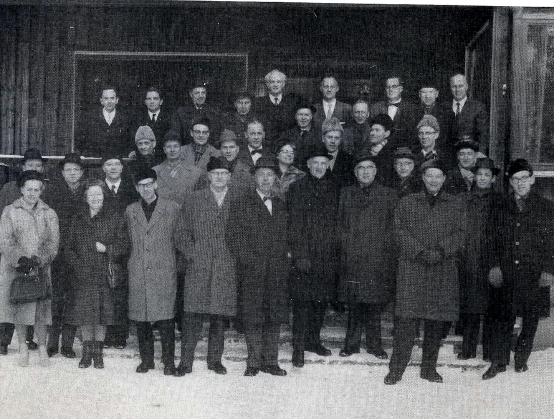

KunskapsCentrum
School development and school leadership
Karlstads Universitet
www.kc.kau.se

The Swedish school system consists of preschool (for children 1-5 years old) preschool class (for 6 year olds), grund school (for 7-16 years old) and gymnasie school (for 17-19 year old). It is a comprehensive school system avoiding streaming before gymnasie school.
Sweden has today 290 kommuns. These are geographical areas with certain political and administrative autonomy in relation to the state. The largest kommun is Stockholm with about 800 000 inhabitants. Bjurholm is one of the smallest with 2 500 inhabitants

